Systems Integration Framework

v0.5 (DRAFT)
Table of Contents
2 Document Control 4
2.1 Document History 4
2.2 Document Authors 4
2.3 Document Assurance 5
2.4 Document References 5
3 Executive Summary 6
3.1 Background and Purpose 6
3.2 Scope 6
3.3 Framework Outcomes 6
4 Architectural Position 7
4.1 Architectural Stance 7
4.2 Strategic Objectives 7
4.3 Service Catalogue, Lifecycle and Governance 7
4.4 Principles 8
5 Reference Architecture 10
5.1 Conceptual Architecture 10
5.2 Logical Layered Architecture 11
5.3 Security and Trust Boundary 12
5.4 Target Integration Platform 13
6 Decision Guidance 14
6.1 Capability Selection 14
6.2 Profile Selection 15
6.3 Pattern Selection 15
6.4 Common Use Cases 16
7 Enterprise Integration Profiles and Practitioner Patterns 17
7.1 Enterprise Integration Profiles 18
7.2 Practitioner Patterns 24
8 Data Platform Position 38
8.1 Core Position 38
8.2 Appropriate Uses 38
8.3 Inappropriate Uses 38
8.4 Exchange Patterns 38
9 Insurance Integration Scenarios 43
10 Security and Operational Excellence 44
10.1 Security Principles 44
10.2 Data Protection and Classification 45
10.3 Observability and Monitoring 45
10.4 Operational Excellence 46
10.5 Delivery Pipeline 46
11 Guardrails 48
11.1 Mandatory Guardrails 48
11.2 Per-Pattern Security Conformance 48
12 Governance 55
12.1 Profile and Pattern Conformance Evidence 55
12.2 Security Conformance 57
12.3 Exceptions 57
13 Glossary 58
14 Definition 59
15 Cross-Reference and Traceability 60
15.1 Pattern Grouping 60

Document Control
This section provides a history of how the document has been changed and how the changes have been governed.

Document History
The following provides a log of changes to this document:
Version | Date | Author | Notes
0.1 | 11/09/2026 | Puneet Kumar | Initial Draft
0.2 | 14/09/2026 | Puneet Kumar | Details added for per pattern security considerations
0.3 | 15/09/2026 | Puneet Kumar | Incorporating feedback from review sessions
0.4 | 25/09/2026 | Puneet Kumar | Updated document structure, references, diagrams, and formatting following internal review
0.5 | 28/09/2026 | Puneet Kumar | Incorporated Steve’s feedback across sections

Document Authors
Role | Name | Title
Author | Puneet Kumar | Consulting Integration Architect
Author | Nikhil Rokade | Portfolio Architect
Author | Joycell Sundararaj | Integration Architect
Contributor | Phanindra Nizalapuram | Integration Architect
Contributor | Pragyan Tripathy | Integration Developer

Document Assurance
This document has been reviewed and approved by the following, the list has been grouped into different sections to aid readability as this document will be required at TDA.

Role | Description
Information | Shared for informational purposes including use as reference document for their domain’s documentation and processes
Reviewer | Actively reviews the content to ensure alignment to guidelines and policies and technical accuracy, will contribute as required
Approver | Provides assurance that their domain is correct in context of the HLSA

Role | Name | Title
Reviewer | Kosta Konstantinov | Enterprise Architect
Reviewer | Steve Coldwell | CTO
Reviewer | Kate Enright | Head of Data
Reviewer | Ryan Freund | Information Security Officer
Reviewer | Dave Ewles | Data Engineering Lead
Reviewer | Chad Ozdil | Security Architect
Reviewer | Jamie Barclay | Cloud Architect
Information | Diana Constable | Head of Engineering

Document References
The following documents should be read in conjunction with this document:

Reference | Document
1 | Enterprise Architecture Principles
2 | Data Classification Policy
3 | Enterprise DevOps Principles
4 | Engineering Standard AIS
5 | Engineering Standard Cloud
6 | SIF & APIM Design Requirements
7 | ChArch-CFG-AzurePolicy
8 | Cloud Security Framework

Executive Summary

Background and Purpose
Integration is a critical enabler of Chaucer’s technology strategy, supporting automation, straight-through processing, improved system-to-system data flow and consistent integration with suppliers, SaaS platforms and other third parties. Chaucer has established modern integration capabilities using Azure Integration Services, but these coexist with point-to-point connections, application-specific interfaces and data-platform exchanges that have developed independently which can result in duplicated capabilities, inconsistent design decisions, tighter coupling and increased change complexity.
The Systems Integration Framework provides a consistent enterprise approach for designing, implementing and governing integration across internal applications, third-party services and the enterprise data platform. It establishes common architectural direction so that recurring integration requirements are addressed through reusable services, approved patterns and standard platform capabilities rather than being redesigned for each initiative.
The framework translates Chaucer’s existing enterprise architecture, cloud, security and engineering principles into practical integration guidance. It is designed to give delivery teams and suppliers clear direction while enabling consistent review and assurance through the Technical Design Authority.

Scope
The Systems Integration Framework covers the following.
- A reference architecture for integration across Azure Integration Services.
- An enterprise catalogue of approved integration patterns with the Azure components for each.
- Decision guidance, guardrails and an exception process for delivery teams and suppliers.
- The position of the data platform boundary and the approved exchange patterns with Data Platform.
The following are out of scope for this version.
- Implementation, provisioning and deployment, which are future-phase activities.
- The API Management high-level design will be produced as a separate phase.
- Any redefinition of Chaucer's cloud strategy.

Framework Outcomes

The Systems Integration Framework establishes:
- A single reference architecture for integration across internal systems, external parties, SaaS services and the data platform.
- Enterprise Integration Profiles that classify the interaction, boundary, control posture and governance treatment.
- Detailed Integration Patterns for APIs, messaging, eventing, streaming, orchestration, file exchange, transformation and data-platform exchange.
- Decision guidance for selecting the appropriate profile, pattern and Azure platform capability.
- A private-by-default security model with controlled ingress, egress and data-platform boundaries.
- Mandatory guardrails covering identity, connectivity, data protection, observability, resilience and delivery.
- Architecture traceability from the business requirement through profile and pattern selection to platform capabilities, controls and governance evidence.
- A controlled exception process for justified deviations from approved patterns, technologies or architectural boundaries.

Architectural Position

Architectural Stance
The Systems Integration Framework takes a clear and consistent position, summarised below and expanded in the sections that follow.
Area | Position
Architecture model | Service-Oriented Architecture, not microservices.
Primary objective | Integrate and reuse existing systems and services before creating new ones. [Ref 1]
Service model | Business-capability aligned enterprise services. [Ref 1]
Integration style | API-led, event-capable, orchestration-supported. [Ref 1]
Platform alignment | Azure PaaS integration services. [Ref 1]
Governance model | TDA-approved standards, reusable patterns, controlled exceptions.

Strategic Objectives

Objective | SIF Direction
Increase automation | Promote API, events, and workflow-based integrations over manual re-keying.
Reduce point-to-point integrations | Introduce reusable service contracts, APIM-mediated APIs, and shared messaging patterns.
Improve system-to-system data flow | Standardized integration approaches across synchronous, asynchronous, file, and data-platform exchange.
Enable vendor integration | Provide secure, governed, and reusable ingress / egress patterns for external suppliers and systems.
Support straight-through processing | Use orchestration where business process coordination is required; avoid embedding logic in consuming systems.
Align to Azure PaaS | Use Azure API Management, Logic Apps, Service Bus, Event Grid, Event Hubs, Azure Functions, and Azure Data Factory as the primary Azure PaaS integration components, with ADF specifically positioned for data ingestion, ELT orchestration, and controlled Data Platform exchange rather than real-time operational integration.

Service Catalogue, Lifecycle and Governance

Defining a service is only the starting point, governance ensures it delivers long-term value. Every service meeting our core criteria must be registered in the Enterprise Service Catalogue- the single source of truth for platform integration. Unregistered services cannot consume or expose platform capabilities.
Each service has:
- Catalogue & Ownership: Each entry maps directly to a business capability, holding a documented contract, semantic versioning, and a named Service Owner accountable for its operation and evolution, maintain a documented, versioned contract and follow approved version management practices.
- Lifecycle Management: Services progress through five explicit states: Proposed, Approved, Active, Deprecated, and Retired. Transitions require Technical Design Authority (TDA) review to guarantee alignment and security.
- Change & Stability: Contract updates must maintain backward compatibility. Deprecation follows a managed timeline, ensuring downstream consumers transition smoothly before retirement.

Principles

Note: The SIF is grounded in Chaucer's Enterprise Architecture and Cloud Engineering principles and does not redefine them. It either complies, extends, or reconciles those principles within the integration domain so that every integration decision traces back to a ratified principle rather than a new one.

Two principles take precedence over all others.
- Reuse is preferred over build - Recommendation is to check the service catalogue for an existing service or API before provisioning a new one.
- Favour integrating with an existing system over standing up new infrastructure – There is no approved pattern for a direct, unmediated connection between two systems, as all integration flows through the approved integration platform using an approved integration pattern.

Principle | Statement | Practical Implication | Source
Loose coupling by default (Integration)  [Ref 1] | Systems should interact through contracts, APIs, messages, or events rather than direct dependencies. | Avoid direct database access, shared file dependencies, and tightly coupled point-to-point calls unless explicitly approved. | Ref architecture (5), Decision Guidance (6.2 and 6.3), Catalogue (7)
Reuse before new build (Global EA, Application)  [Ref 1] | Reuse of existing services, APIs, workflows, and platform components must be assessed before creating new integrations. | Every design should document reuse assessment. | Architectural Position (4), Catalogue (7), Guardrails (11.1)
Business capability alignment (Application)  [Ref 1] | Services should expose meaningful business capabilities, not raw system internals. | APIs should represent business functions such as policy, claim, submission, party, document, or finance capability. | Architectural Position (4), Catalogue (7)
APIM as API publishing and ingress control (Integration, Security)  [Ref 1]  [Ref 8] | Chaucer-owned APIs exposed for internal or external consumption should be published through Azure API Management unless an exception is approved. | APIM is the standard control point for API discovery, policy enforcement, authentication, throttling, monitoring, versioning, and lifecycle governance. Direct exposure of backend APIs, Logic Apps, Functions, or internal service endpoints should be avoided. | Ref architecture (5), Security (10), Guardrails (11.1)
Third-party API egress is governed by reuse and risk (Integration, Security)  [Ref 1] | Chaucer integrations may call third-party APIs directly from Logic Apps or Functions where the integration is workflow-specific, low reuse, and appropriately governed. | APIM should be used as a Chaucer-owned facade where third-party APIs are reused, business-critical, strategically important, externally sensitive, or require centralised policy, monitoring, or lifecycle control. | Catalogue (7), Governance (12)
Asynchronous-first where resilience matters (Integration, Resilience)  [Ref 1] | When availability, retry, load levelling, or latency tolerance is important, prefer messaging/events. | Use Service Bus queues/topics for reliable enterprise messaging. | Decision Guidance (6.2 and 6.3), Catalogue (7)
Orchestration usage is explicit (Integration) [Ref 1] | Cross-system business process must have explicit ownership and coordination within integration platform rather being embedded in consuming applications, scripts or custom code. | Logic Apps Standard is the default orchestrator. Azure Durable Functions may be used only as an explicitly declared and governed orchestrator where the published selection criteria are met. Plain Azure Functions must not become hidden orchestration engines. | Catalogue (7)
Implementation logic is separated (Integration)  [Ref 1] | Low-level code should be isolated from orchestration and API policy concerns. | Functions should implement narrow code tasks. They should not be implemented in end-to-end business workflows. | Catalogue (7)
Secure by design (Security)  [Ref 1]  [Ref 8] | Managed identities for authentication, RBAC, private endpoints where possible, Credentials, secrets, and certificates must be securely managed through an approved enterprise capability, with access monitoring, least-privilege access, and auditability enforced by default | Security patterns should be explicitly included in every design review. | Security (10), Guardrails (11.1)
Observable by default (Engineering Standards)  [Ref 1] | Every integration must be traceable, monitored, and supportable. | Correlation IDs, diagnostics, alerts, and operational runbooks are mandatory to ensure long term supportability. | Security (10), Guardrails (11.1)
Data platform is not integration technology (Data)  [Ref 1] | The data platform should not be used as a substitute for operational integration. | Data platform should be used as intended for analytical, historical, reporting, and governance across data products. | Data Platform (8)

Reference Architecture

Conceptual Architecture

At the conceptual level the Systems Integration Framework places a single integration layer between the consumers of integration and the systems, suppliers and data platform that provide or receive information. The integration layer is the only sanctioned route between parties. It presents governed contracts to consumers, mediates protocol and format, and applies security, routing and observability consistently.

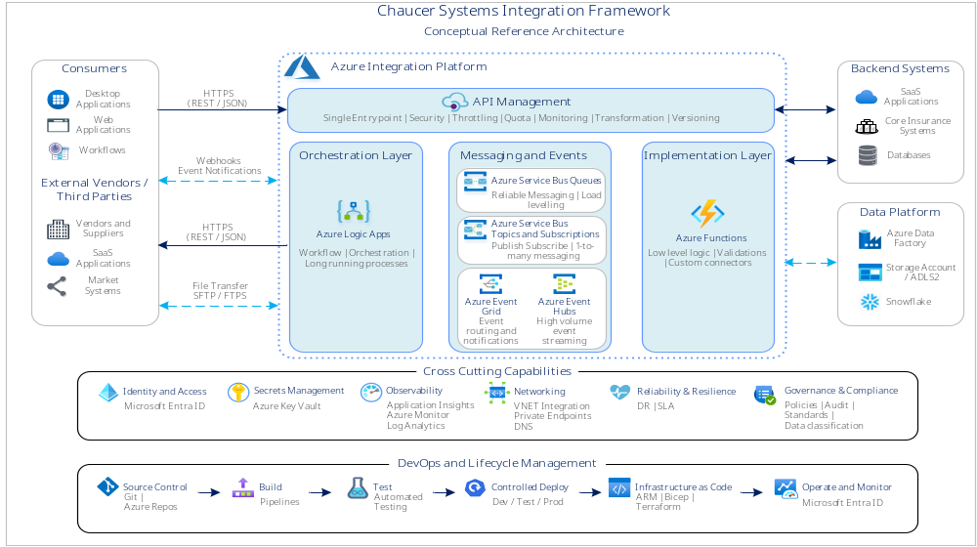

Logical Layered Architecture

The logical view resolves the conceptual layer into five bands. The diagram should be read from the consumer to the systems and data platform at the base.
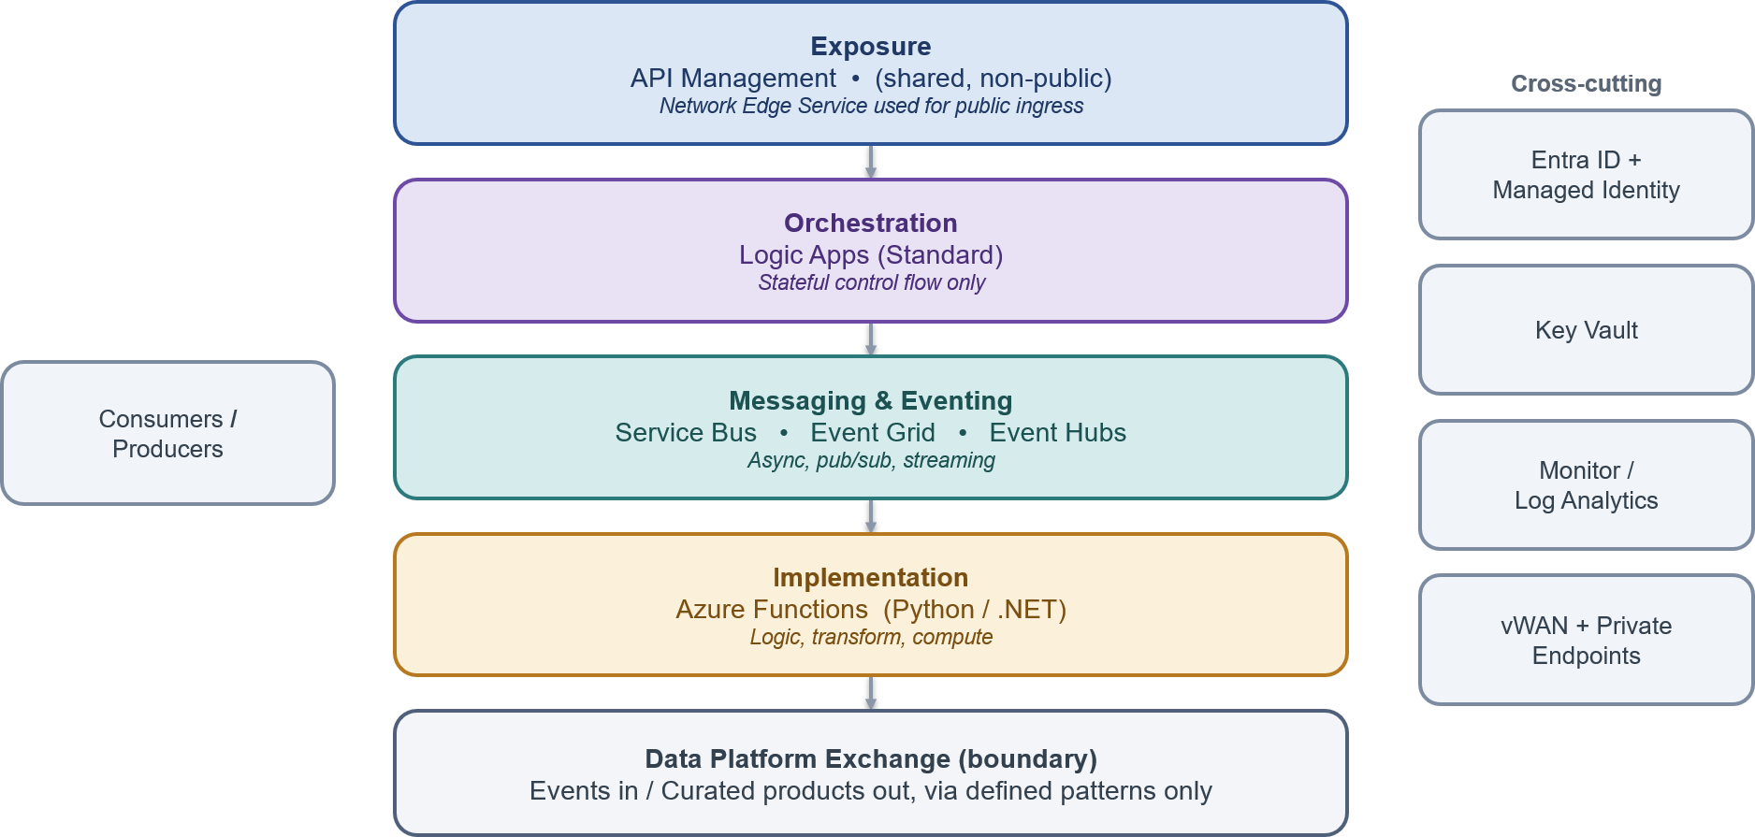
Layer | Description
Exposure layer | API Management is the single ingress for synchronous traffic, applying authentication, rate limiting, product and subscription control, and observability.
Orchestration layer | Logic Apps coordinate stateful, multi-step business processes. and own workflow control rather than embedding process logic within consuming applications or systems. Logic Apps Standard is the default orchestration platform. Azure Durable Functions may be used only as an explicitly declared and governed orchestrator where the approved selection criteria and exception process are met. Plain Azure Functions must not be used as hidden orchestration engines.
Messaging and eventing layer | Service Bus, Event Grid and Event Hubs provide asynchronous messaging, discrete eventing and streaming respectively.
Implementation layer | Azure Functions host the discrete implementation logic invoked by the layers above.
Data platform boundary | The Systems Integration Framework meets Data Platform at two governed hand-offs only: a push into the platform and a curated consume from it.

Security and Trust Boundary

Security is the principle the organisation takes most seriously. The Systems Integration Framework sets out the trust zones once and holds every pattern to them. The diagram shows the zones a request crosses and the control at each boundary.
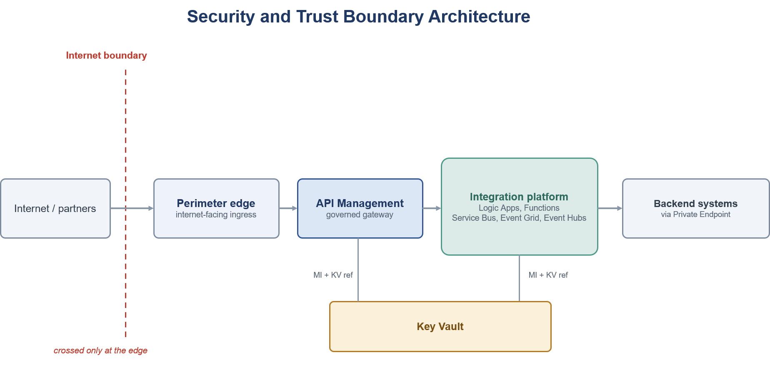
Layer | Description
Internet boundary | The line between the public internet and the estate. It is crossed only at the edge, and public exposure is an exception approved separately rather than a default.
Perimeter edge | The internet-facing ingress and the only point where the boundary is crossed. Anything reachable from outside is fronted here by a managed edge that applies the required protections and keeps everything behind it privately connected. The edge technology is chosen with security and network stakeholders.
APIM gateway | The single, non-public control point for APIs. It authenticates callers, applies policy, throttling and versioning, and mediates all API traffic. It is internal and is never exposed to the internet directly.
Integration platform | The private runtime where integrations execute, providing messaging, eventing, orchestration and lightweight compute. It runs on the private network and is reached only through the gateway or private connectivity.
Backends and data | Systems of record and the analytical data platform. Both are reached only over private connectivity and authenticated by identity, never on a public path. The data platform is reached across a governed boundary, not on the live operational path.
Secrets and certificates | Held in a managed store and referenced by identity at run time, never copied into configuration or code.

Target Integration Platform

The Systems Integration Framework standardises on the following Azure Integration Services which have been selected as part of the requirements - [Ref 6]
Delivery teams are expected to select from these components and are expected to implement integration solutions conforming to Chaucer’s Azure policies and Azure Integration Services engineering standards introduce. [Ref 5, 8]
Component | Systems Integration Framework Role | Recommended Use | Do Not Use
Azure API Management | Enterprise API gateway and single API ingress point | Exposing REST APIs to internal systems, vendors, applications, or digital channels | For long-running business processes or data transformation pipelines
Azure Logic Apps | Workflow orchestration and cross-system process coordination | Multi-step integrations, long-running workflows, connector-based automation, exception paths | For low-level compute-heavy logic or high-throughput streaming
Azure Service Bus | Reliable enterprise messaging | Guaranteed delivery, commands, queues, topics, retries, dead-letter handling | For lightweight notifications where message state is not required
Azure Event Grid | Event notification and reactive event routing | Resource/event notifications, event fan-out, near-real-time triggers | For ordered business messaging or complex message settlement
Azure Event Hubs | High-throughput event streaming | Telemetry, high-volume event ingestion, streaming analytics | For command-style workflow messaging or request/response integration
Azure Functions | Low-level implementation logic | Lightweight code extensions, transformation helpers, protocol adapters, custom validation | As the default orchestration engine or business process owner (plain Functions chained into hidden orchestration). Azure Durable Functions is permitted only as an explicit, declared orchestrator under the Orchestration Patterns selection criteria.
Azure Data Factory | Data ingestion and analytical pipeline orchestration | Batch/ELT, Data Platform loading, analytical data movement | Real-time operational integration or transient system-to-system messaging

Decision Guidance

Capability Selection
The matrix below provides a high-level guide to selecting the most appropriate integration capability for a given requirement. It identifies whether a platform capability is normally suitable, conditionally suitable, or not recommended for a specific interaction style. The enterprise pattern catalogue in Section 7 remains the authoritative source for detailed pattern guidance.

Does the need involve... | API | Functions | Service Bus | Event Grid | Event Hubs | Logic Apps | ADF
A consumer that needs an immediate response | ✅ | ⚠️ | ❌ | ❌ | ❌ | ⚠️ | ❌
Guaranteed delivery | ⚠️ | ❌ | ✅ | ⚠️ | ⚠️ | ⚠️ | ❌
A business command or transaction | ✅ | ⚠️ | ✅ | ❌ | ❌ | ⚠️ | ❌
A small code-based transformation or enrichment | ⚠️ | ✅ | ⚠️ | ❌ | ❌ | ⚠️ | ⚠️
A notification that something happened | ⚠️ | ⚠️ | ⚠️ | ✅ | ⚠️ | ⚠️ | ❌
High-volume telemetry or an event stream | ❌ | ⚠️ | ⚠️ | ❌ | ✅ | ❌ | ❌
A process that spans multiple systems and steps | ⚠️ | ⚠️ | ⚠️ | ⚠️ | ❌ | ✅ | ❌
Long-running state or retry orchestration | ❌ | ❌ | ⚠️ | ❌ | ❌ | ✅ | ❌
Analytics or data warehousing as the main purpose | ❌ | ❌ | ⚠️ | ⚠️ | ⚠️ | ⚠️ | ✅

Legend.
✅ Preferred service for the stated use case.
⚠️ Possible service where specific requirements justify its use.
❌ Not normally recommended for the stated use case.

Profile Selection

The decision trees below resolve an integration requirement to a profile and pattern family based on interaction style, timing and delivery guarantees. The catalogue in Section 7 describes the chosen profile and pattern.
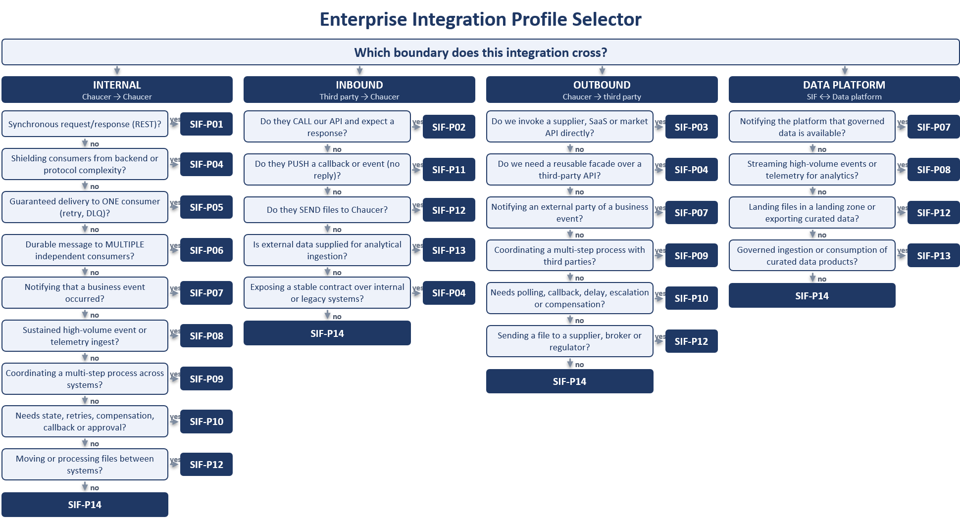

Pattern Selection
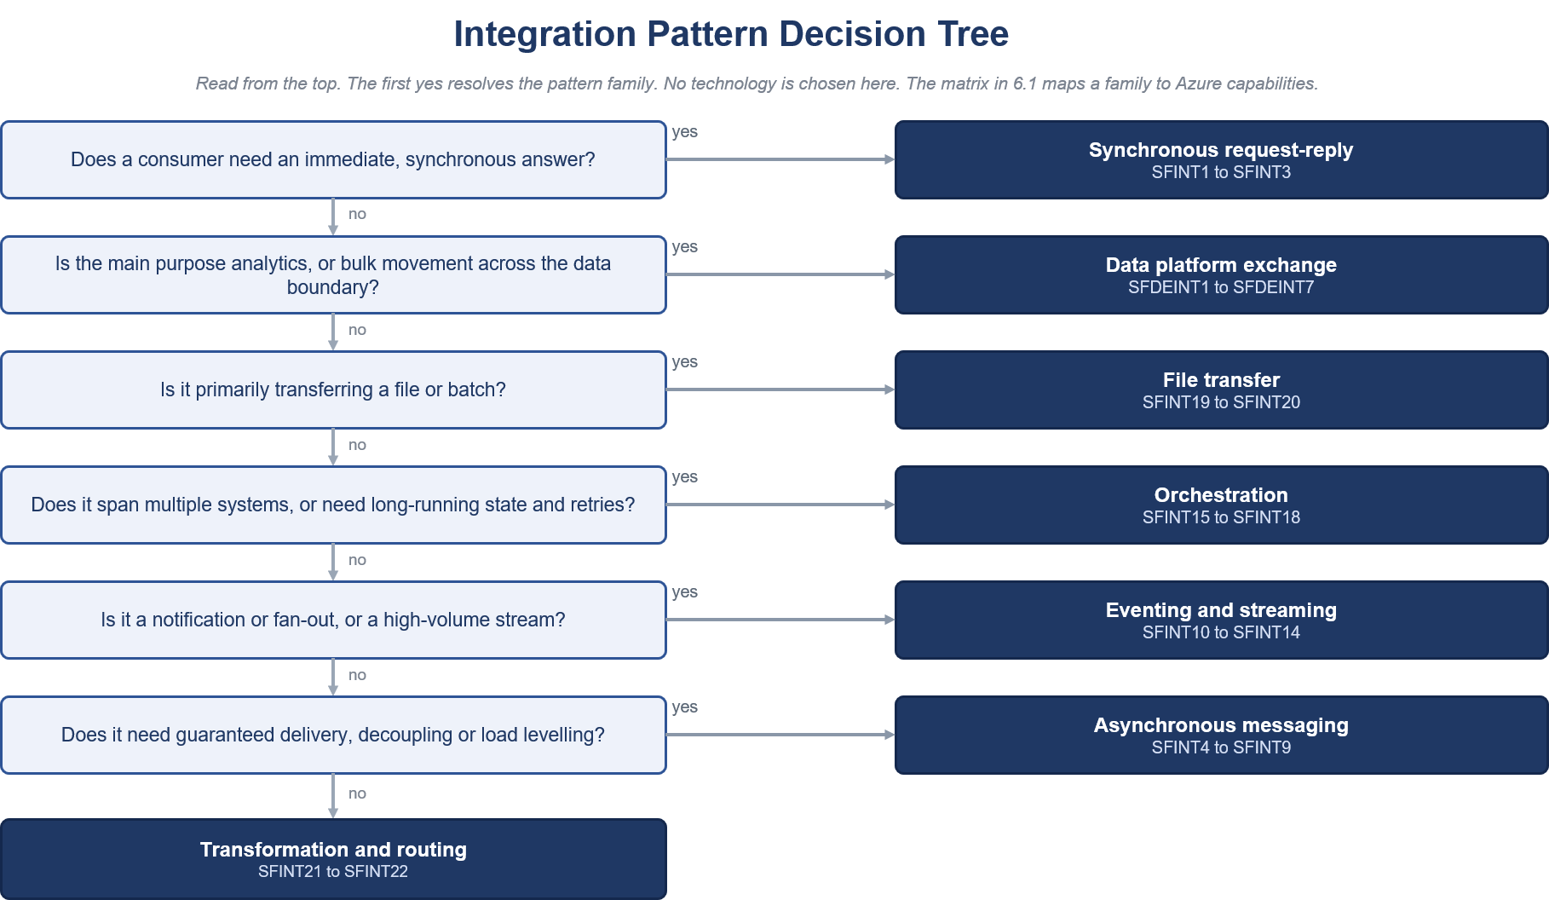

Common Use Cases

The table maps everyday scenarios to the recommended pattern and to the catalogue entry that specifies it in full.
Scenario | Recommended pattern | Catalogue reference
Retrieve or update business data immediately | REST API through API Management | SFINT1
Tell another system to perform work, where delayed processing is acceptable | Service Bus queue, load levelling | SFINT4
Have multiple systems react to the same business message | Service Bus topic, publish and subscribe | SFINT10
Notify that a resource change or event occurred | Event Grid notification | SFINT11
Ingest a high-volume stream, telemetry or near-real-time feed | Event Hubs stream ingestion | SFINT14
Run a multi-step process with conditional routing and exception handling | Logic Apps orchestration | SFINT15
Apply a small code-based transformation or validation step | Azure Function, message translator | SFINT21
Ingest a batch into the Data Platform for reporting or analytics | Data platform patterns, ADF, Blob | Section 8
Run an operational real-time transaction between applications | API or messaging pattern | SFINT1 to SFINT9

Enterprise Integration Profiles and Practitioner Patterns

The Systems Integration Framework defines a governed catalogue for selecting, designing and reviewing integrations across internal Chaucer systems, third-party services, SaaS platforms and the enterprise data platform.

The catalogue has two complementary levels:
- Enterprise Integration Profiles classify the enterprise interaction, the boundary crossed, the expected governance treatment and the applicable control posture.
- Detailed Integration Patterns define the implementation approach used to realise an Enterprise Integration Profile.
These levels are complementary and must not be treated as competing pattern catalogues. An Enterprise Integration Profile describes the architectural context of an integration. A Detailed Integration Pattern describes how a specific part of the integration is implemented. One Enterprise Integration Profile may be realised through several Detailed Integration Patterns, and one Detailed Integration Pattern may support more than one Enterprise Integration Profile.

For example, the same Managed API Facade pattern may be used for an internal API, an externally consumed Chaucer API or a governed facade over a third-party API. The implementation pattern is similar, but the trust boundary, security controls and governance evidence differ.

Every architecture design must identify:
- The selected Enterprise Integration Profile.
- The integration boundary crossed.
- Each Detailed Integration Pattern used to realise the integration.
- The applicable security, operational and data-handling controls.
- The governance evidence required for the selected profile and patterns.
- Any approved exception or deviation.
The expected architecture traceability is:
Business requirement → Enterprise Integration Profile → Detailed Integration Pattern or Patterns → Approved platform capability → Mandatory guardrails → Governance evidence

- Enterprise Integration Profiles use the identifier format SIF-Pnn.
- Operational Integration Patterns use the identifier format SFINTnn.
- Data-platform exchange patterns use the identifier format SFDEINTnn.
- The Detailed Integration Pattern identifier is authoritative for implementation guidance. The Enterprise Integration Profile identifier is authoritative for boundary classification and governance assessment.

Enterprise Integration Profiles

Enterprise Integration Profiles provide the architecture and governance view of an integration.

Each profile identifies:
- The enterprise interaction being performed.
- The primary integration boundary.
- Where the profile is normally applicable.
- The primary platform capabilities.
- The expected governance classification.
- The Detailed Integration Patterns that may realise the profile.
Internal integrations may use approved API, messaging, eventing, orchestration, file-exchange, transformation and routing patterns within Chaucer’s controlled integration platform.

Third-party integrations must use an approved ingress or egress profile. These integrations require additional controls for identity, authentication, network boundaries, payload validation, data protection, monitoring, operational ownership and support.
The data platform is treated as a governed analytical exchange boundary. It is not the default mechanism for operational integration, transient messaging, real-time transaction processing or cross-system process orchestration.

Applicability and Governance Classifications
The following applicability notation is used throughout the catalogue:
Symbol | Meaning
✅ | The profile is normally applicable to the boundary.
⚠️ | The profile may be applicable but requires additional design rationale, controls or governance review.
❌ | The profile is not normally appropriate for the boundary.

The following governance classifications are used:
Governance classification | Meaning
Standard | The profile may be used through the normal architecture-governance route when all mandatory guardrails are satisfied.
Standard with boundary controls | The profile crosses an organisational, external, internet or data-platform boundary and requires the additional controls defined for that boundary.
Conditional | Use requires documented selection rationale and confirmation that the stated conditions are satisfied.
Exception required | Use deviates from an approved pattern, technology, guardrail or boundary and requires formal exception approval before implementation.
Not applicable | The profile is not an appropriate solution for the stated boundary or requirement.
A profile classified as Standard with boundary controls does not automatically require an exception. An exception is required only when the implementation cannot satisfy the approved boundary controls or otherwise deviates from the Systems Integration Framework.

Profile Catalogue

Profile ID | Enterprise Integration Profile | Primary boundary | Internal | Third party to Chaucer | Chaucer to third party | SIF to data platform | Primary capabilities | Governance classification
SIF-P01 | Internal REST API | Internal | ✅ | ❌ | ❌ | ⚠️ | API Management with backend API, Logic App or Function | Standard
SIF-P02 | External API Ingress | Third party to Chaucer | ⚠️ | ✅ | ❌ | ❌ | Approved network edge and API Management | Standard with boundary controls
SIF-P03 | External API Egress | Chaucer to third party | ⚠️ | ❌ | ✅ | ⚠️ | API Management, Logic Apps or Functions | Standard with boundary controls
SIF-P04 | API Facade and Mediation | Internal or external | ✅ | ✅ | ✅ | ⚠️ | API Management with Logic App or Function | Standard, with boundary controls where external
SIF-P05 | Reliable Queue Messaging | Primarily internal | ✅ | ⚠️ | ⚠️ | ⚠️ | Service Bus Queue | Standard internally; controlled externally
SIF-P06 | Publish and Subscribe Messaging | Primarily internal | ✅ | ⚠️ | ⚠️ | ⚠️ | Service Bus Topic and subscriptions | Standard internally; controlled externally
SIF-P07 | Event Notification | Internal or external | ✅ | ⚠️ | ✅ | ✅ | Event Grid, Service Bus Topic or Logic App | Standard internally; boundary controls where external
SIF-P08 | High-Volume Event Streaming | Internal, analytical or selected external | ✅ | ⚠️ | ⚠️ | ✅ | Event Hubs | Conditional
SIF-P09 | Workflow Orchestration | Internal or external | ✅ | ✅ | ✅ | ⚠️ | Logic Apps Standard | Standard, with boundary controls where external
SIF-P10 | Long Running and Stateful Workflow | Internal or external | ✅ | ✅ | ✅ | ⚠️ | Logic Apps Standard or approved Durable Functions | Standard for Logic Apps; Durable Functions by approved exception
SIF-P11 | Third-Party Webhook Ingress | Third party to Chaucer | ⚠️ | ✅ | ❌ | ❌ | Approved network edge, API Management and asynchronous processing | Standard with boundary controls
SIF-P12 | Managed File Exchange | Internal or external | ✅ | ✅ | ✅ | ✅ | Logic Apps, Functions, Storage, SFTP and Event Grid | Standard internally; boundary controls where external
SIF-P13 | Data Platform Exchange | SIF to data platform or data platform to governed consumer | ⚠️ | ⚠️ | ⚠️ | ✅ | ADF, ADLS, APIs and other technologies chosen by the Data Platform | Conditional; not an operational integration default
SIF-P14 | Specialist Mediation and Transformation | Internal or external | ✅ | ✅ | ✅ | ⚠️ | Functions, API Management, Service Bus or Event Grid | Standard with constraints
Profile Interpretation

The Primary capabilities column identifies the normal platform capabilities used to realise the profile. It does not prescribe every component required in an end-to-end design.
The Detailed Integration Patterns remain authoritative for:
- Pattern-selection criteria.
- Implementation structure.
- Appropriate and inappropriate use.
- Security boundaries.
- Operational considerations.
- Reliability and resilience controls.
- Common pitfalls.
- Representative insurance scenarios.
Any implementation that requires a technology not included in the target platform or an arrangement not covered by an approved profile and Detailed Integration Pattern requires documented architecture justification and approval through the exception process.

Relationship to Integration Patterns
The following table maps each Enterprise Integration Profile to the Practitioner Pattern(s) that may be used to realise it. The mapping identifies permitted and commonly applicable patterns. It does not imply that every listed pattern is required in every implementation.

Enterprise Integration Profile | Profile name | Commonly applicable Practitioner Patterns | Detailed section
SIF-P01 | Internal REST API | SFINT01 Managed API Facade | 7.2.2.1
SIF-P02 | External API Ingress | SFINT01 Managed API Facade | 7.2.2.1
SIF-P03 | External API Egress | SFINT01 Managed API Facade; SFINT03 Protocol and Format Mediation; SFINT09 Scheduled or Timed Trigger; SFINT15 Stateful Process Orchestration | 7.2.2.1, 7.2.2.2 and 7.2.2.3
SIF-P04 | API Facade and Mediation | SFINT01 Managed API Facade; SFINT02 API Composition and Aggregation; SFINT03 Protocol and Format Mediation | 7.2.2.1
SIF-P05 | Reliable Queue Messaging | SFINT04 Queue-Based Load Levelling; SFINT05 Competing Consumers; SFINT06 Asynchronous Request-Reply; SFINT07 Claim-Check; SFINT08 Reliable Messaging; SFINT09 Scheduled or Timed Trigger | 7.2.2.2
SIF-P06 | Publish and Subscribe Messaging | SFINT10 Publish-Subscribe Fan-Out | 7.2.2.3
SIF-P07 | Event Notification | SFINT11 Discrete Event Notification; SFINT13 Outbound Webhook or Notification | 7.2.2.3
SIF-P08 | High-Volume Event Streaming | SFINT14 Stream and Telemetry Ingestion | 7.2.2.3
SIF-P09 | Workflow Orchestration | SFINT15 Stateful Process Orchestration; SFINT18 Scatter-Gather | 7.2.2.4
SIF-P10 | Long Running and Stateful Workflow | SFINT15 Stateful Process Orchestration; SFINT16 Process with Compensation; SFINT17 Human-in-the-Loop Approval; SFINT18 Scatter-Gather | 7.2.2.4
SIF-P11 | Third-Party Webhook Ingress | SFINT12 Inbound Webhook Ingestion | 7.2.2.3
SIF-P12 | Managed File Exchange | SFINT09 Scheduled or Timed Trigger; SFINT19 Event-Driven File Ingestion; SFINT20 File Generation and Delivery | 7.2.2.2 and 7.2.2.5
SIF-P13 | Data Platform Exchange | SFDEINT01 to SFDEINT09 | 8.4
SIF-P14 | Specialist Mediation and Transformation | SFINT03 Protocol and Format Mediation; SFINT21 Canonical Data Model and Message Translator; SFINT22 Content-Based Routing | 7.2.2.1 and 7.2.2.6

Profile Grouping by Integration Boundary
Internal Chaucer Integration Profiles
Profile ID | Enterprise Integration Profile | Typical use | Key Controls / Governance Considerations
SIF-P01 | Internal REST API | Synchronous access to a governed business capability. | Standard
SIF-P04 | API Facade and Mediation | Shield consumers from backend implementation, protocol or system complexity. | Standard
SIF-P05 | Reliable Queue Messaging | Decouple producers and consumers while providing delivery guarantees and retry handling. | Standard
SIF-P06 | Publish and Subscribe Messaging | Distribute durable business messages to multiple independent consumers. | Standard
SIF-P07 | Event Notification | Notify internal consumers that a business or resource event has occurred. | Standard
SIF-P08 | High-Volume Event Streaming | Ingest sustained event or telemetry streams. | Conditional
SIF-P09 | Workflow Orchestration | Coordinate multi-step business processes across systems. | Standard
SIF-P10 | Long-Running and Stateful Workflow | Coordinate state, retries, compensation and approvals across extended business processes. | Standard for Logic Apps; Exception Required for Durable Functions
SIF-P12 | Managed File Exchange | Move or process files between Chaucer systems through governed controls. | Standard
SIF-P14 | Specialist Mediation and Transformation | Perform controlled protocol, format, validation or routing transformations. | Standard with Constraints

Third Party to Chaucer Inbound Profiles
Profile ID | Enterprise Integration Profile | Typical use | Key Controls / Governance Considerations
SIF-P02 | External API Ingress | A third party invokes a Chaucer-owned API. | Approved edge, API Management, authentication, authorization, throttling, validation, monitoring and backend isolation.
SIF-P04 | API Facade and Mediation | Expose a stable contract while shielding internal systems and legacy interfaces. | Contract ownership, versioning, backend isolation, schema validation and controlled public exposure.
SIF-P11 | Third-Party Webhook Ingress | A third party pushes a callback or event to Chaucer. | Approved edge, API Management, signature or token validation, replay protection, rate limiting, deduplication and asynchronous downstream processing.
SIF-P12 | Managed File Exchange | A third party delivers files to Chaucer. | Approved file-transfer channel, encryption, source authentication, validation, reconciliation and metadata capture.
SIF-P13 | Data Platform Exchange | External data is supplied for analytical ingestion. | Data ownership, classification, lineage, landing-zone controls, ingestion monitoring and approved Data Platform ownership.
SIF-P14 | Specialist Mediation and Transformation | An inbound payload requires protocol conversion, canonical translation, validation or routing. | Transformation remains private and is invoked only after approved ingress controls have been applied.

Chaucer to Third Party Outbound Profiles

Profile ID | Enterprise Integration Profile | Typical use | Key Controls / Governance Considerations
SIF-P03 | External API Egress | Chaucer invokes a third-party API. | Controlled egress, credential management, timeout handling, throttling, circuit breaking and dependency monitoring.
SIF-P04 | API Facade and Mediation | Provide a reusable facade over a third-party API. | Contract abstraction, versioning, supplier lifecycle management and centralised policy control.
SIF-P07 | Event Notification | Notify an external party that a business event has occurred. | Authentication, delivery audit, retry, dead-letter handling and payload protection.
SIF-P09 | Workflow Orchestration | Coordinate a multi-step process involving external systems. | Named process ownership, controlled egress, dependency monitoring and compensating actions.
SIF-P10 | Long-Running and Stateful Workflow | Manage callbacks, polling, delayed responses or compensation with external parties. | Durable state, timeout handling, retries, escalation and support ownership.
SIF-P12 | Managed File Exchange | Deliver files to suppliers, brokers, regulators or vendors. | Approved delivery path, encryption, reconciliation, retention and support ownership.
SIF-P14 | Specialist Mediation and Transformation | Apply supplier-specific payload, format, validation or protocol transformation. | Source-controlled mappings, testing, private execution, Key Vault/CyberArk integration and DevSecOps deployment.

SIF to Data Platform Profiles
Profile ID | Enterprise Integration Profile | Typical use | Key Controls / Governance Considerations
SIF-P07 | Event Notification | Notify the Data Platform that governed data is available for ingestion. | Notification only. The Data Platform must not coordinate operational processes.
SIF-P08 | High-Volume Event Streaming | Stream telemetry or events into the Data Platform. | Use only where the streaming requirement and expected volume are justified.
SIF-P12 | Managed File Exchange | Land files in a governed landing zone or export curated data through a controlled file boundary. | Ownership, classification, metadata, retention, reconciliation and monitoring must be defined.
SIF-P13 | Data Platform Exchange | Governed ingestion into, or governed consumption from, the Data Platform. | The Data Platform must not become the default operational integration mechanism.
SIF-P14 | Specialist Mediation and Transformation | Perform bounded extraction, validation, redaction or format preparation at the exchange boundary. | Operational process orchestration and warehouse transformation logic must not be embedded in custom integration code.

Practitioner Patterns

The Detailed Integration Pattern Catalogue is the authoritative source for pattern implementation guidance. Patterns are organised by interaction style:

- Request and response.
- Asynchronous messaging.
- Eventing and streaming.
- Process orchestration.
- File exchange.
- Transformation and routing.
- Data-platform exchange.
The catalogue is aligned to the decision process in Section 7. The decision tree first identifies the appropriate interaction style. The detailed catalogue then provides the approved pattern for implementing that interaction.

Pattern Identifiers
The following identifier formats are used
Identifier format | Scope | Example
SFINTnn | Operational integration patterns | SFINT8 Reliable Messaging
SFDEINTnn | Data-platform exchange patterns | SFDEINT03 File Ingestion
The Detailed Integration Pattern identifier must be used in:
- High-level and low-level solution designs.
- Architecture decision records.
- Interface and integration specifications.
- Service-catalogue entries.
- Security and operational-readiness assessments.
- Exception requests.
- TDA submissions.
- Delivery and support documentation.
A design must reference both the pattern identifier and the pattern name.

For example:
Selected pattern: SFINT8 Reliable Messaging

Pattern Catalogue
A Detailed Integration Pattern may be used through the normal governance process when:

- The pattern is selected consistently with the decision guidance in Section 6.
- The associated Enterprise Integration Profile is applicable to the boundary.
- Approved platform capabilities are used.
- All mandatory guardrails are satisfied.
- The required security and operational evidence are present.
- No prohibited anti-pattern is introduced.
Exceptions must be recorded and approved in accordance with Sections 11 and 12.

API Patterns

Managed API Facade (SFINT1)
Expose a governed business capability without coupling consumers to its implementation.
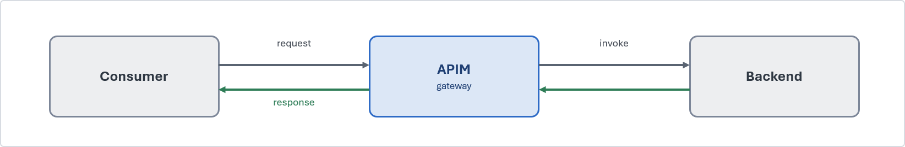
Problem. Consumers require synchronous access to a capability, but direct backend integration creates tight coupling and inconsistent controls.
Solution. Publish a coarse-grained REST/JSON contract through API Management. APIM authenticates and authorises the caller, applies gateway policies and invokes the backend through approved private connectivity.
When to use. A consumer requires an immediate response through a reusable, discoverable and governed API.
When to avoid. Processing is long-running, asynchronous or dependent on several coordinated steps.
Risks and considerations. Keep gateway policies lightweight. Define timeouts, versioning, caching and backend failure behaviour.
Security boundary. APIM and the backend remain private. External APIs enter through the approved network edge, with APIM positioned behind it.
Common pitfall. Using APIM as a pass-through proxy or embedding business and orchestration logic in gateway policies.
In practice. A broker portal retrieves policy information through an API without connecting directly to the policy administration system.

API Composition / Aggregation (SFINT2)
Present a single business response assembled from a small number of backend service
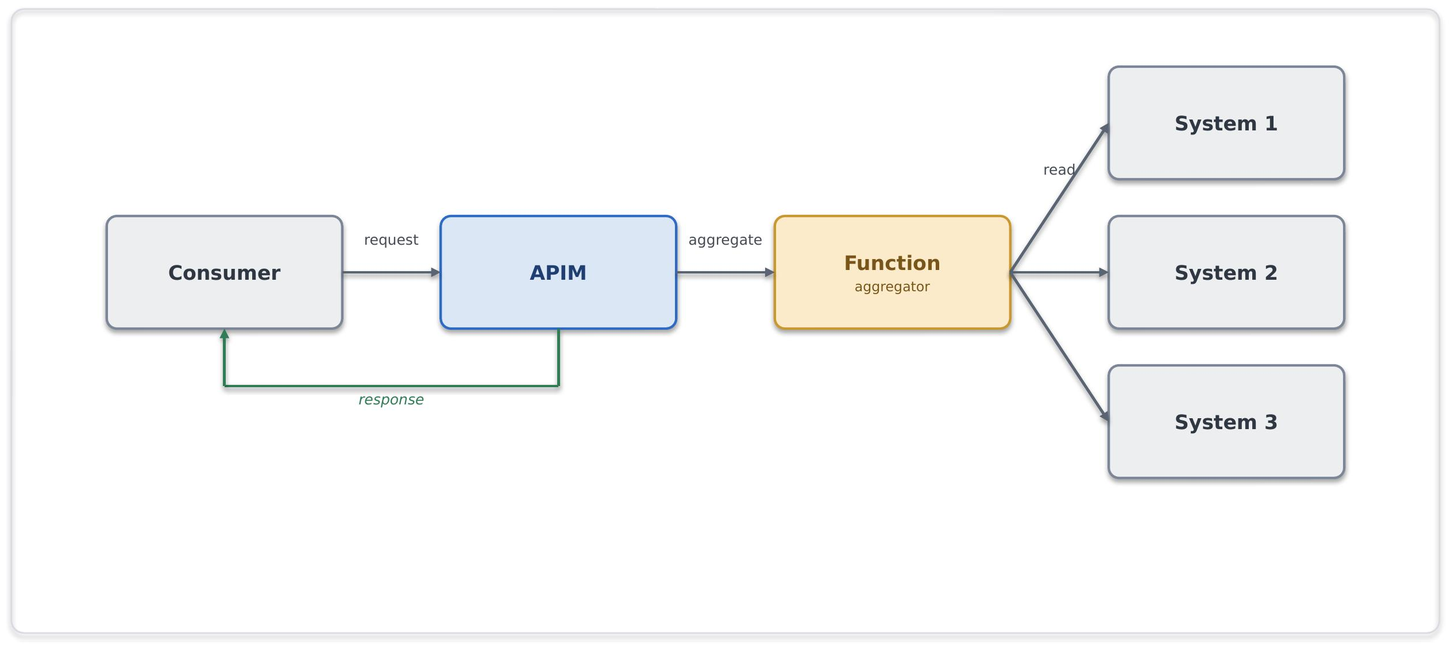
Problem. A consumer requires related information held across several systems, creating multiple dependencies and client-side aggregation.
Solution. Expose one API through APIM and use a composition service to call the required backends and assemble the response.
When to use. A consumer needs one logical business view from a limited number of sources.
When to avoid. The operation includes transactional writes, long-running work or extensive fine-grained service calls.
Risks and considerations. Define backend timeouts, partial-response behaviour, caching and dependency-failure handling.
Security boundary. APIM, the composition service and backends use private connectivity, managed identities and TLS.
Common pitfall. Creating a chatty distributed dependency or implementing complex aggregation in APIM policies.
In practice. A servicing application retrieves a consolidated client view across policy, claims and customer systems.

Protocol / Format Mediation (SFINT3)
Translate between technical protocols or formats without exposing legacy complexity to consumers.
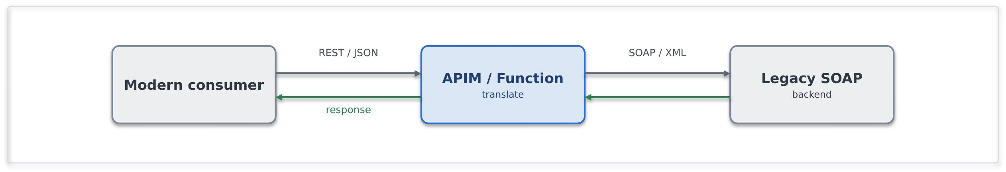
Problem. A consumer and backend use incompatible protocols, formats or interface standards.
Solution. Use APIM or a Function to perform bounded, stateless protocol and format conversion.
When to use. A legacy or specialist interface must be presented through a standard REST/JSON contract.
When to avoid. The requirement includes business transformation, process coordination or complex enrichment.
Risks and considerations. Validate schemas and keep mediation stateless, testable and limited to technical conversion.
Security boundary. The mediation component remains private. Azure and on premises backends use approved private connectivity.
Common pitfall. Embedding business rules or extensive transformation in gateway policies.
In practice. A legacy SOAP/XML reinsurance service is presented to consumers through a REST/JSON interface.

Messaging Patterns

Queue-Based Load Levelling (SFINT4)
Absorb variable producer demand while protecting a constrained consumer
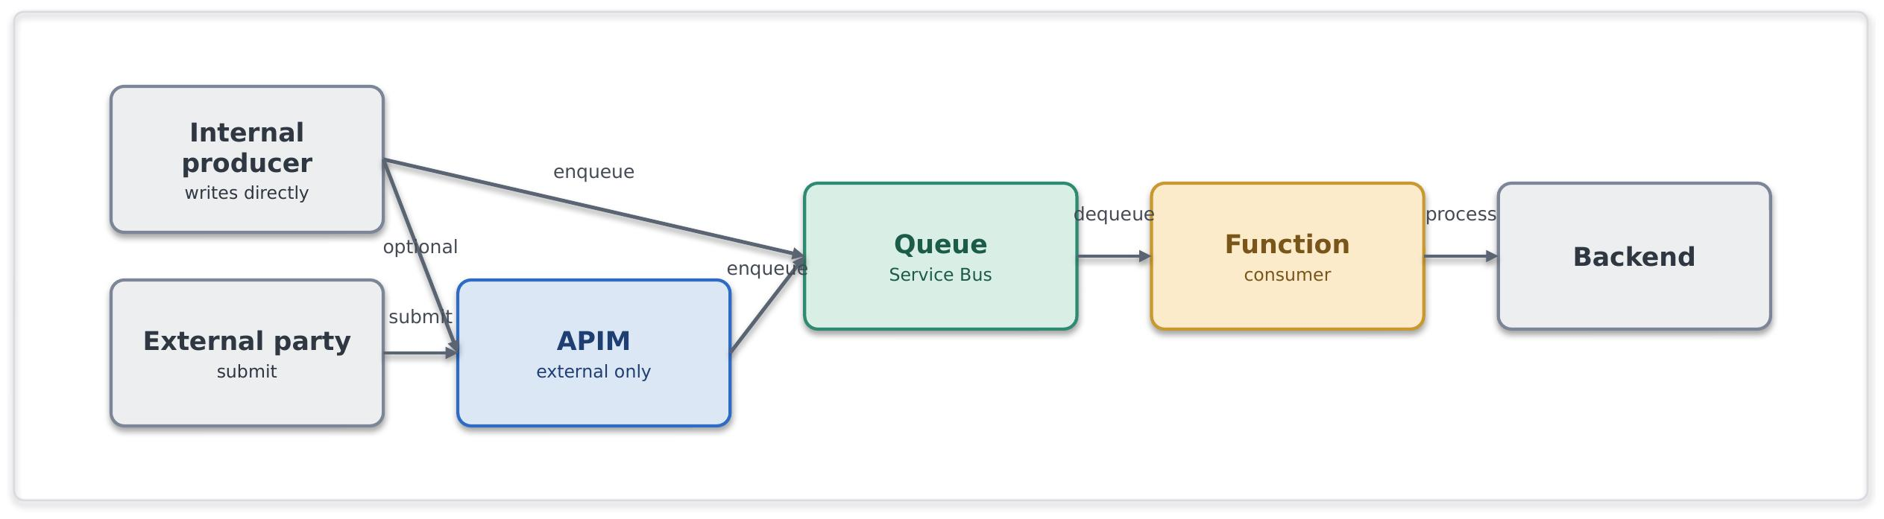
Problem. A producer generates work faster or less predictably than the consumer can process it.
Solution. Place a Service Bus queue between producer and consumer so they operate independently. Consumers process messages at a controlled rate.
When to use. Load is variable, delayed processing is acceptable, or backend availability must be isolated from producers.
When to avoid. The caller requires an immediate result, or the workload is a continuous high-volume stream.
Risks and considerations. Monitor queue depth, message age, consumer lag and dead-letter activity. Consumers must be idempotent.
Security boundary. Producers and consumers use private connectivity, managed identity and separate Sender and Receiver permissions. External producers enter through an approved ingress pattern.
Common pitfall. Treating a queue as unlimited storage or failing to operate the dead-letter queue.
In practice. Broker submissions are queued during renewal peaks and processed at a rate the policy platform can sustain.

Competing Consumers (SFINT5)
Increase throughput by processing independent messages across multiple workers
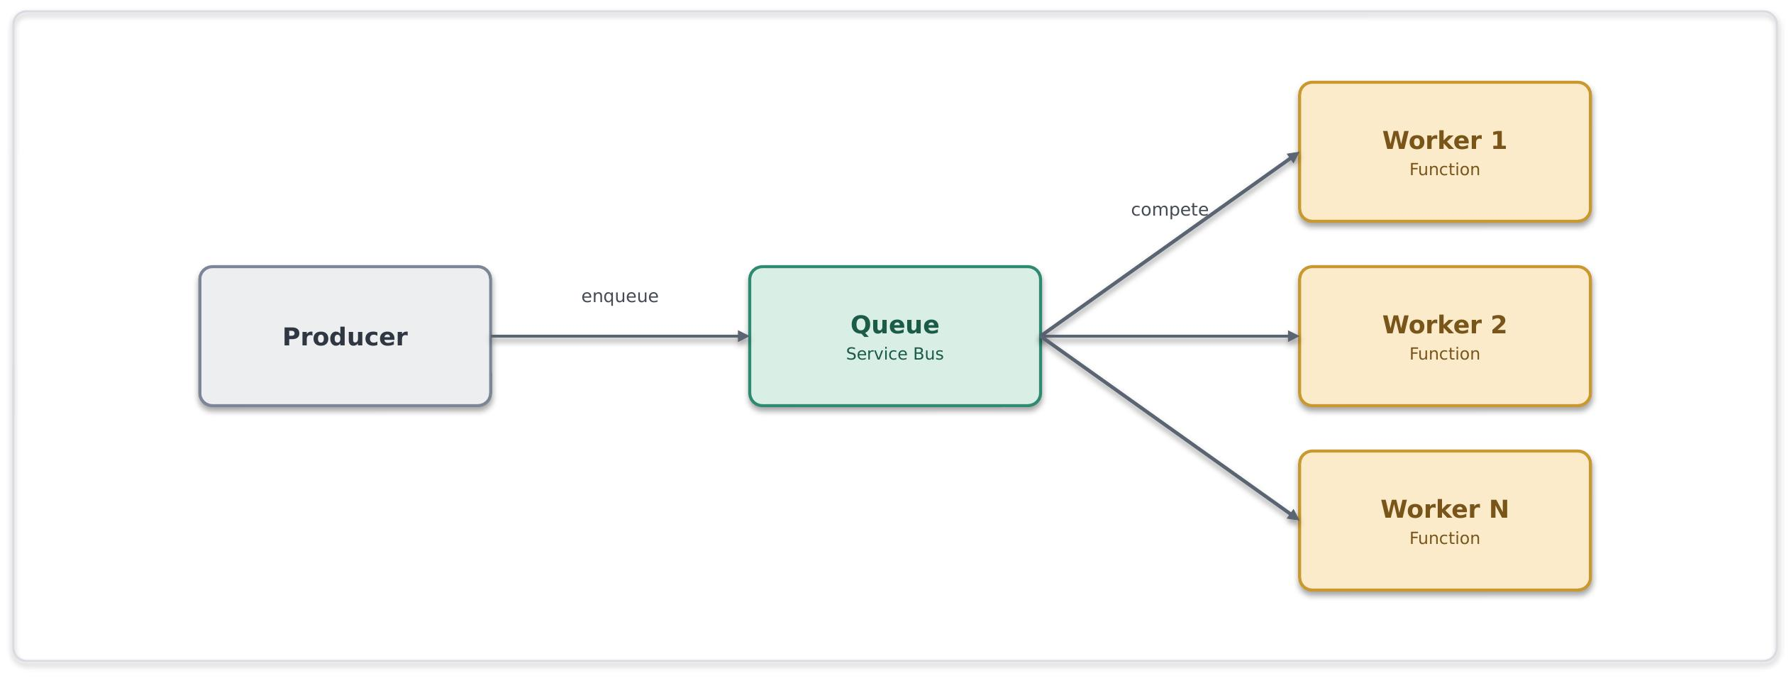
Problem. A single consumer cannot process queued work at the required rate.
Solution. Run multiple consumer instances against one Service Bus queue and scale them according to queue demand.
When to use. Work items are independent and can be processed concurrently.
When to avoid. Global ordering is required or consumers depend on shared mutable state.
Risks and considerations. Consumers must be idempotent. Define concurrency limits and monitor hot sessions and queue backlog.
Security boundary. Service Bus and workers remain private, using managed identity, least-privilege Receiver access and TLS.
Common pitfall. Assuming message ordering without sessions or scaling workers without protecting downstream systems.
In practice. An autoscaling worker pool clears a backlog of document-processing jobs.

Asynchronous Request-Reply (SFINT6)
Accept a request immediately and provide the result when processing completes.
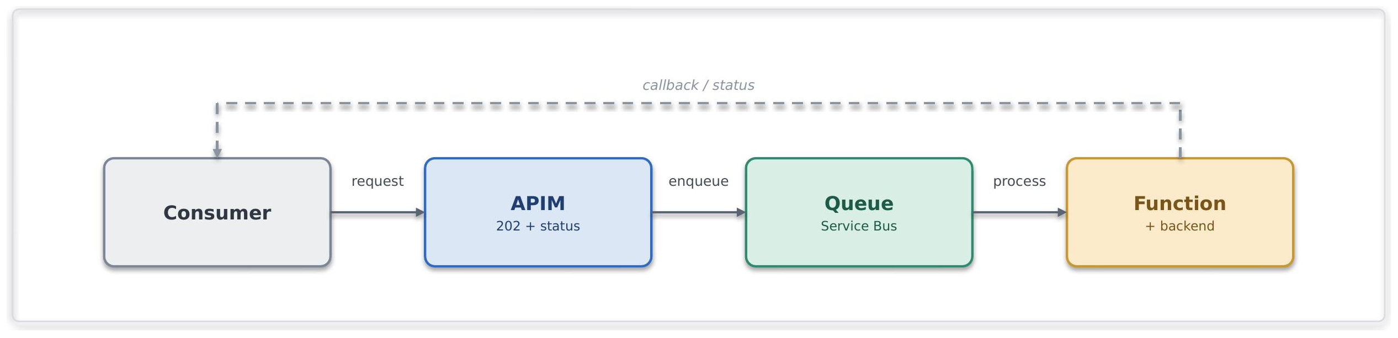
Problem. An operation cannot complete within a normal synchronous response window, but the caller still requires the result.
Solution. APIM accepts the request and returns an accepted response with a correlation identifier and status endpoint. Processing continues asynchronously through Service Bus and a worker.
When to use. Processing is long-running and the caller needs status or an eventual response.
When to avoid. The result is immediately available, or the interaction cannot support request-to-result correlation.
Risks and considerations. Define status states, retention, expiry, callback behaviour and cleanup of completed requests.
Security boundary. Request, status and callback components use private connectivity, managed identity and TLS. External endpoints use the approved edge and APIM.
Common pitfall. Holding the original connection open or exposing predictable, unauthorised status URLs.
In practice. A bulk quotation request is accepted immediately, and its result is retrieved later through a status endpoint.

Claim-Check (SFINT7)
Store a large payload separately and place only its reference on the message.
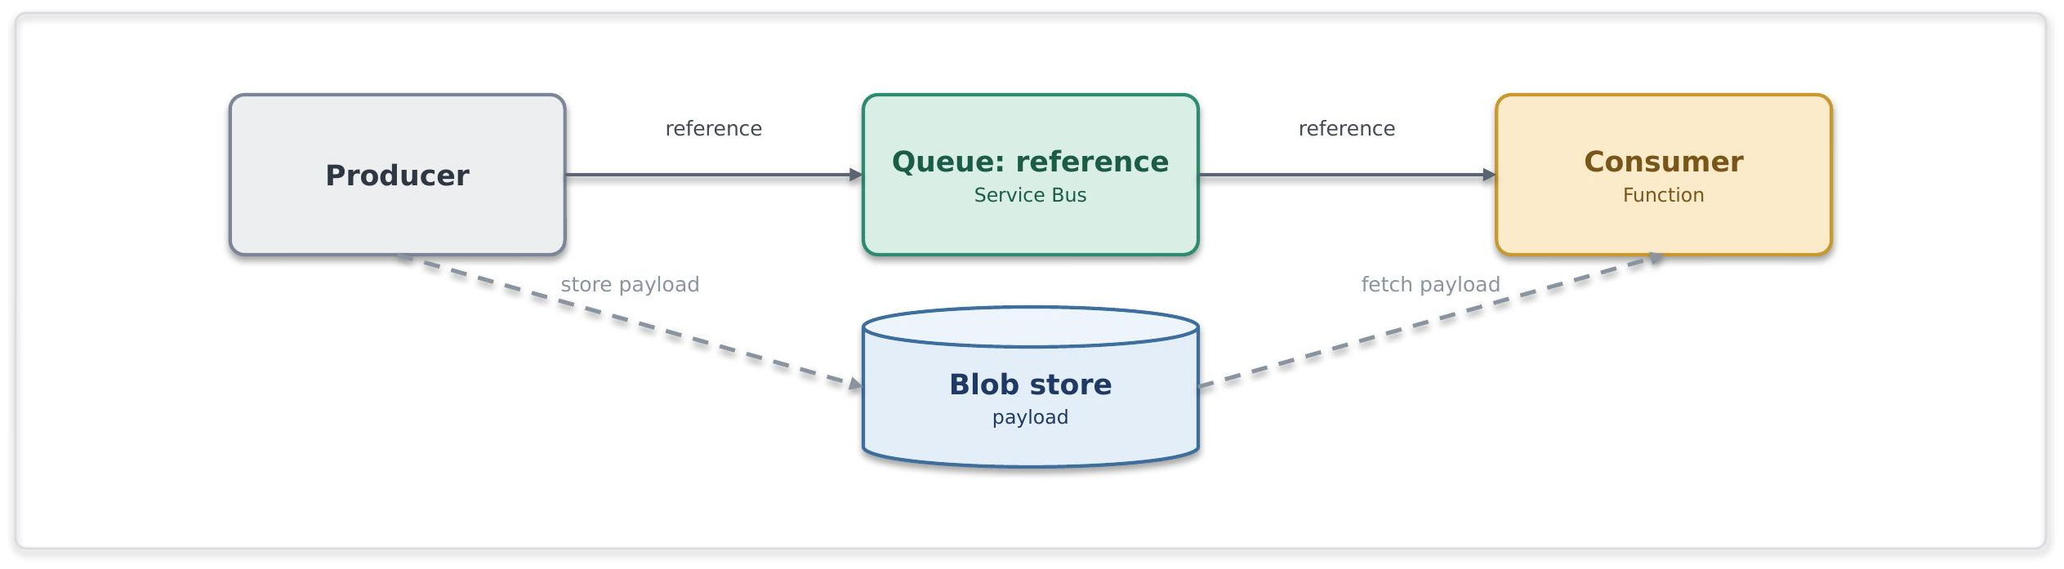
Problem. A payload is unsuitable for direct transport through the messaging service because of its size.
Solution. Store the payload in Blob Storage and send a secure reference through Service Bus. The consumer retrieves the payload when processing the message.
When to use. An otherwise message-based integration must handle large payloads.
When to avoid. The payload fits within the approved message size or belongs to a bulk data-platform flow.
Risks and considerations. Align payload retention with message lifetime and ensure missing or expired references can be handled.
Security boundary. Blob Storage and Service Bus remain private. Access uses managed identity and RBAC, without account keys or public SAS URLs.
Common pitfall. Sending large binaries through Service Bus or using public, long-lived payload references.
In practice. A large bordereau is stored in Blob Storage while Service Bus carries its processing reference.

Reliable Messaging (SFINT8)
Deliver business-critical messages reliably and prevent duplicate business outcomes.
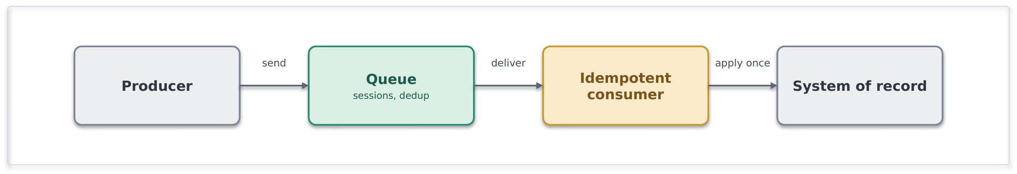
Problem. Message loss or duplicate processing could create financial, operational or data-integrity impacts.
Solution. Use Service Bus with durable delivery, duplicate-detection controls and sessions where ordering is required. Consumers implement idempotent processing.
When to use. A business command or event must not be lost and must be safe to reprocess.
When to avoid. The notification is replaceable and does not require durable business-message handling.
Risks and considerations. Transport delivery remains at least once. Idempotency is the primary control against duplicate outcomes.
Security boundary. Service Bus and consumers use private connectivity, managed identity, least-privilege RBAC and TLS.
Common pitfall. Assuming the transport provides an absolute exactly-once processing guarantee.
In practice. A financial instruction is delivered durably and can be retried without posting the transaction twice.

Scheduled / Timed Trigger (SFINT9)
Start integration work at a defined time when no suitable event is available.

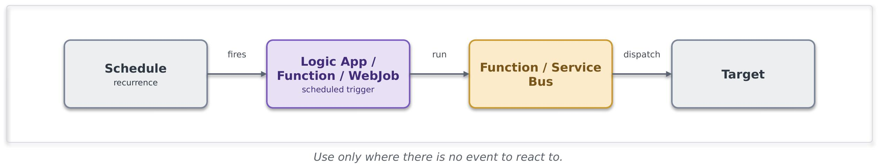
Problem. An integration must run according to a business schedule or because the source cannot publish an event.
Solution. Use a Logic App Standard recurrence trigger or Function timer to initiate processing or publish work to Service Bus.
When to use. Processing is inherently time-based or the source cannot notify the integration platform.
When to avoid. A reliable event exists or polling is being used to simulate real-time processing.
Risks and considerations. Prevent overlapping executions and monitor missed, delayed and failed runs. Schedules must be source-controlled.
Security boundary. The scheduler runs inside the workload boundary and uses managed identity and private connectivity for downstream calls.
Common pitfall. Uncontrolled polling, overlapping runs or schedules with no documented owner.
In practice. A financial reconciliation process runs at the end of each business day.

Event Patterns

Publish / Subscribe Fan-Out (SFINT10)
Publish a durable business message once and distribute it to independent consumers.
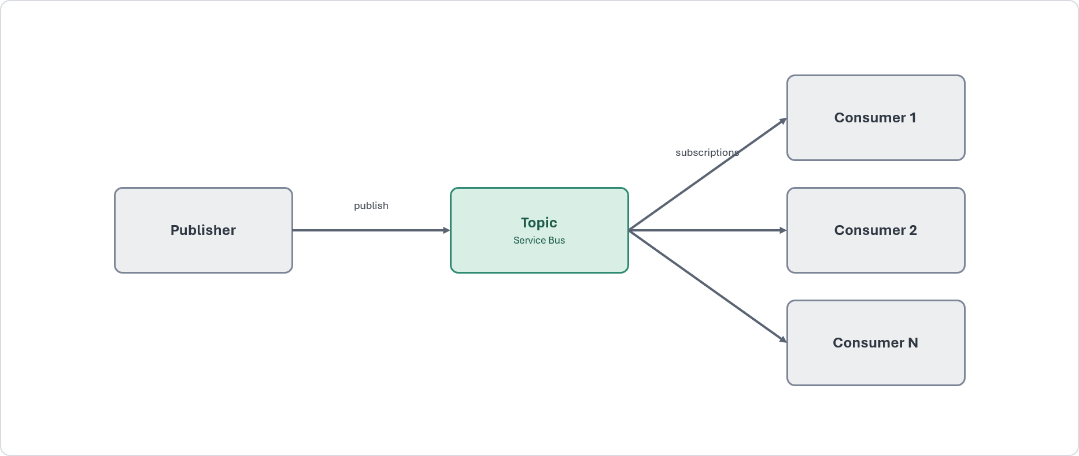

Problem. Several consumers must process the same business message without direct dependencies on the publisher.
Solution. Publish to a Service Bus topic. Each consumer owns a filtered subscription and separate dead-letter queue.
When to use. Multiple consumers require durable, independently managed delivery.
When to avoid. The requirement is a lightweight notification or a continuous high-volume stream.
Risks and considerations. Govern subscription creation and monitor backlog, failures and dead-letter activity for each consumer.
Security boundary. Topics and subscriptions remain private. Publishers and subscribers use separate managed identities and least-privilege permissions.
Common pitfall. Coupling publishers to consumers or using Event Grid where durable business messaging is required.
In practice. A policy-bound message is consumed independently by finance, document and analytics processes.

Discrete Event Notification (SFINT11)
Notify interested handlers that a resource or business state has changed.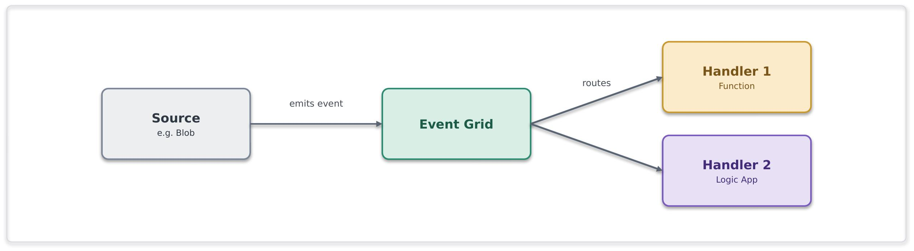
Problem. Consumers must react quickly to a discrete event without requiring durable enterprise messaging.
Solution. Publish a minimal event through Event Grid. Handlers retrieve authoritative state when additional data is required.
When to use. Low-latency, reactive fan-out to Azure-native handlers is required.
When to avoid. Consumers need ordered durable delivery, competing consumers or stream processing.
Risks and considerations. Delivery may be duplicated or unordered. Handlers must be idempotent and order independent.
Security boundary. Event Grid and internal handlers use private connectivity where supported, managed identity and TLS.
Common pitfall. Treating event payloads as the authoritative business record.
In practice. A document-status change triggers independent downstream action.

Inbound Webhook Ingestion (SFINT12)
Receive third-party callbacks through a controlled public boundary and process them privately.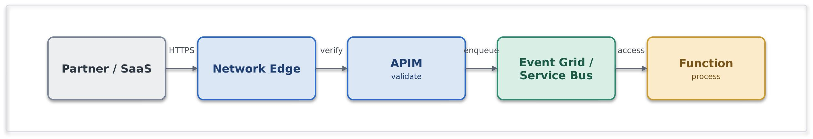
Problem. An external system must push a callback or event to Chaucer without exposing internal integration services directly.
Solution. Terminate public traffic at the approved network edge, route it through APIM, authenticate and validate the request, then hand processing to Service Bus or Event Grid.
When to use. A third party must push events and private connectivity is unavailable.
When to avoid. The integration can use approved private connectivity.
Risks and considerations. Implement replay protection, deduplication, validation, throttling and asynchronous downstream processing.
Security boundary. The pattern crosses the internet boundary. APIM remains behind the approved edge, and all downstream components remain private.
Common pitfall. Directly exposing a Function or Logic App HTTP trigger or processing an untrusted request synchronously.
In practice. A payment provider posts a settlement event that is validated and placed on Service Bus.

Outbound Webhook / Notification (SFINT13)
Push an event or status change to an approved subscriber.
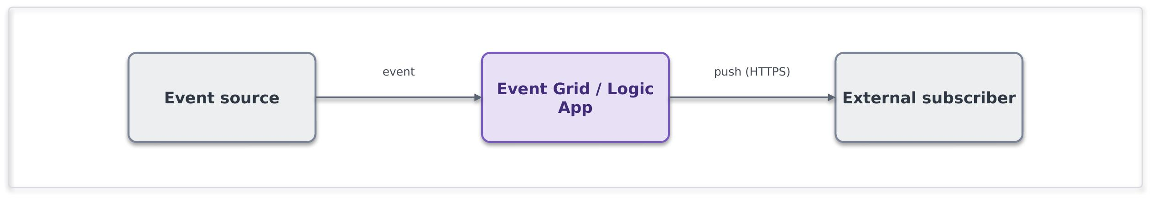
Problem. A consumer requires timely notification without repeatedly polling Chaucer systems.
Solution. Deliver the notification through Event Grid or Logic Apps using a registered destination and approved delivery channel.
When to use. A subscriber needs an event pushed when a defined condition occurs.
When to avoid. The consumer should retrieve current state through an API.
Risks and considerations. Define retry, backoff, dead-letter handling, delivery auditing and circuit-breaking behaviour.
Security boundary. External traffic uses the controlled egress route. TLS, destination restrictions and approved secret management apply.
Common pitfall. Building bespoke dispatch code for each subscriber or using polling to simulate push delivery.
In practice. A broker system receives a notification when a claim status changes.

Stream / Telemetry Ingestion (SFINT14)
Ingest and process continuous, high-volume event streams.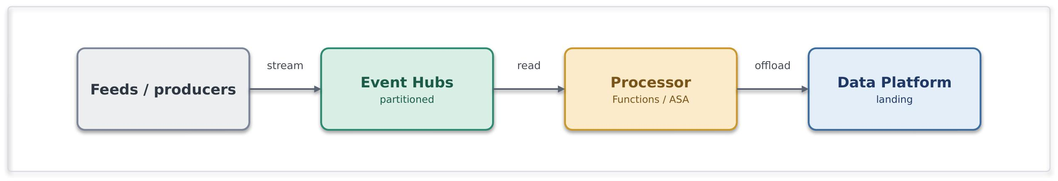

Problem. A high-frequency feed exceeds the intended operating model of business-message queues.
Solution. Ingest the feed through Event Hubs, partition it for throughput and process it through approved stream consumers.
When to use. Sustained event rates require partitioned, scalable stream processing.
When to avoid. The workload consists of transactional commands, ordered business messages or low-volume notifications.
Risks and considerations. Define partitioning, checkpoints, consumer groups, retention and capacity. Ordering is limited to an individual partition.
Security boundary. Event Hubs, processors and capture storage use private connectivity, managed identity, RBAC and TLS.
Common pitfall. Using Event Hubs for transactional commands or Service Bus for high-volume telemetry.
In practice. A continuous exposure feed is processed near real time and supplied to the data platform for analytics.

Orchestration Patterns

Orchestration Technology Selection

Logic Apps Standard is the default platform for integration-centric workflows, connector-based automation, approvals and long-running processes. Durable Functions may be selected only for explicitly declared, code-centric orchestration that cannot reasonably be delivered through Logic Apps Standard. Its selection requires documented justification and TDA approval. Plain Functions must not coordinate an undeclared workflow.

Stateful Process Orchestration (SFINT15)
Coordinate a multi-step business process with state, retries and end-to-end visibility.
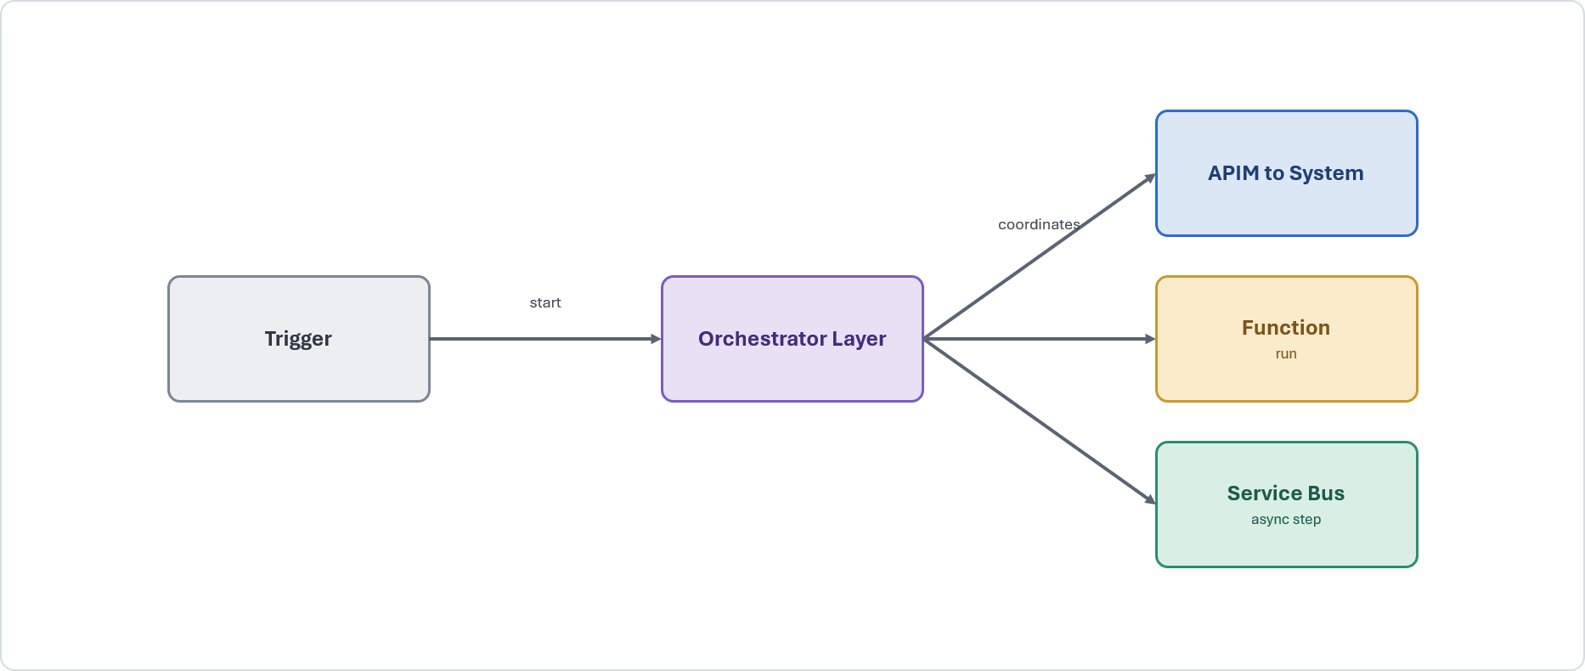
Problem. A process spans several systems and cannot be reliably owned by an individual participating application.
Solution. Use an explicit orchestrator (Logic app/Durable Functions) to sequence steps, maintain state, invoke APIs, delegate discrete computation and publish asynchronous work.
When to use. A cross-system process requires state, retries, timeouts, auditability or long-running execution.
When to avoid. A single API call or a simple queued hand-off meets the requirement.
Risks and considerations. Keep business computation outside the workflow. Design steps for restart ability, idempotency and versioning.
Security boundary. The orchestrator remains private and uses managed identity, approved secrets management, private connectivity and TLS.
Common pitfall. Embedding implementation logic in the workflow or distributing one process across uncoordinated orchestrators.
In practice. A new-business process coordinates validation, pricing, document generation and system updates.

Process With Compensation (SFINT16)
Restore a consistent business outcome when a completed process step must be reversed.

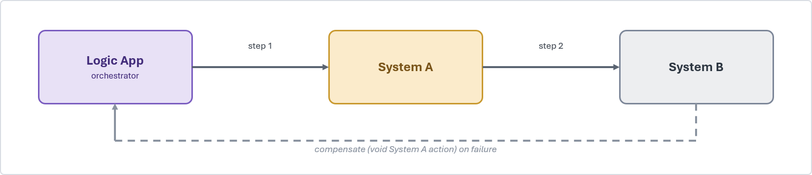
Problem. A later failure occurs after earlier operations have completed across multiple systems.
Solution. Define explicit compensating actions within the owning orchestration and invoke them in a controlled sequence.
When to use. Cross-system consistency is required but a distributed transaction is unavailable or inappropriate.
When to avoid. One system can complete the work within a local transaction.
Risks and considerations. Compensation can fail and must therefore be idempotent, retry able, monitored and auditable.
Security boundary. The orchestrator and compensation services remain private. Access to reversal operations is restricted and audited.
Common pitfall. Treating compensation as an automatic rollback or implementing it without clear process ownership.
In practice. An underwriting workflow reverses completed actions after a downstream financial step fails

Human-in-the-Loop / Approval (SFINT17)
Pause an automated process for an authenticated and auditable human decision.

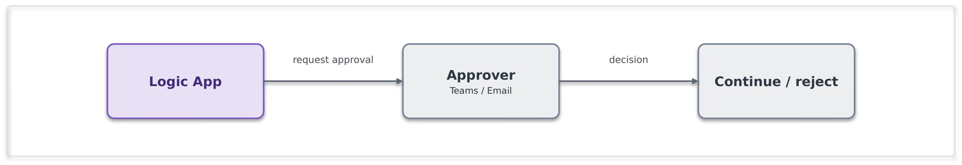
Problem. A workflow requires manual approval before automated processing can continue.
Solution. Use Logic Apps with an approved Microsoft 365 approval channel, recording the approver, decision and decision time.
When to use. Human authority or judgement is required and must be auditable.
When to avoid. The decision can be made reliably through automated rules.
Risks and considerations. Define reminders, timeouts, reassignment and escalation paths.
Security boundary. Approval interactions use approved, identity-authenticated channels. Approval links must not provide transferable or anonymous authority.
Common pitfall. Managing approvals through untracked email with no timeout or escalation.
In practice. An underwriting referral pauses until an authorised underwriter records a decision.

Scatter-Gather (SFINT18)
Run independent activities in parallel and aggregate their results.

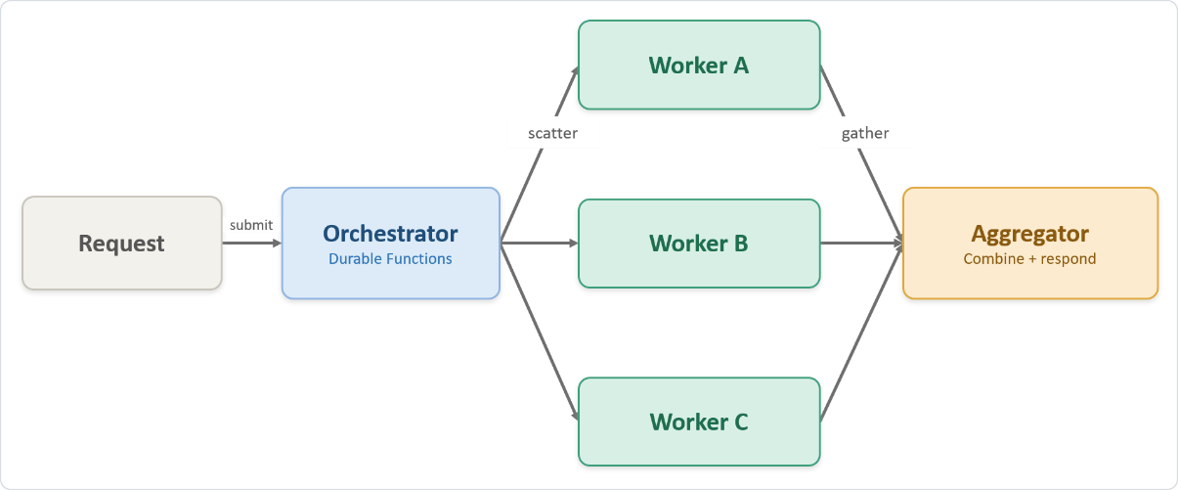

Problem. A process requires results from several independent services, and sequential execution adds unnecessary latency.
Solution. An orchestrator invokes services concurrently, tracks completion and combines the responses.
When to use. Tasks are independent, can run concurrently and must contribute to one combined outcome.
When to avoid. Tasks are sequentially dependent or no aggregated result is required.
Risks and considerations. Define concurrency limits, timeouts, partial-result policy and failure handling.
Security boundary. The orchestrator and workers remain private and use managed identities, RBAC and TLS. External calls use the approved egress pattern.
Common pitfall. Implementing sequential calls or waiting indefinitely for every response.
In practice. Pricing, fraud and capacity checks run concurrently before a quotation is returned.

File Patterns

Event-Driven File Ingestion (SFINT19)
Process an operational file when it arrives and convert its contents into governed integration work.

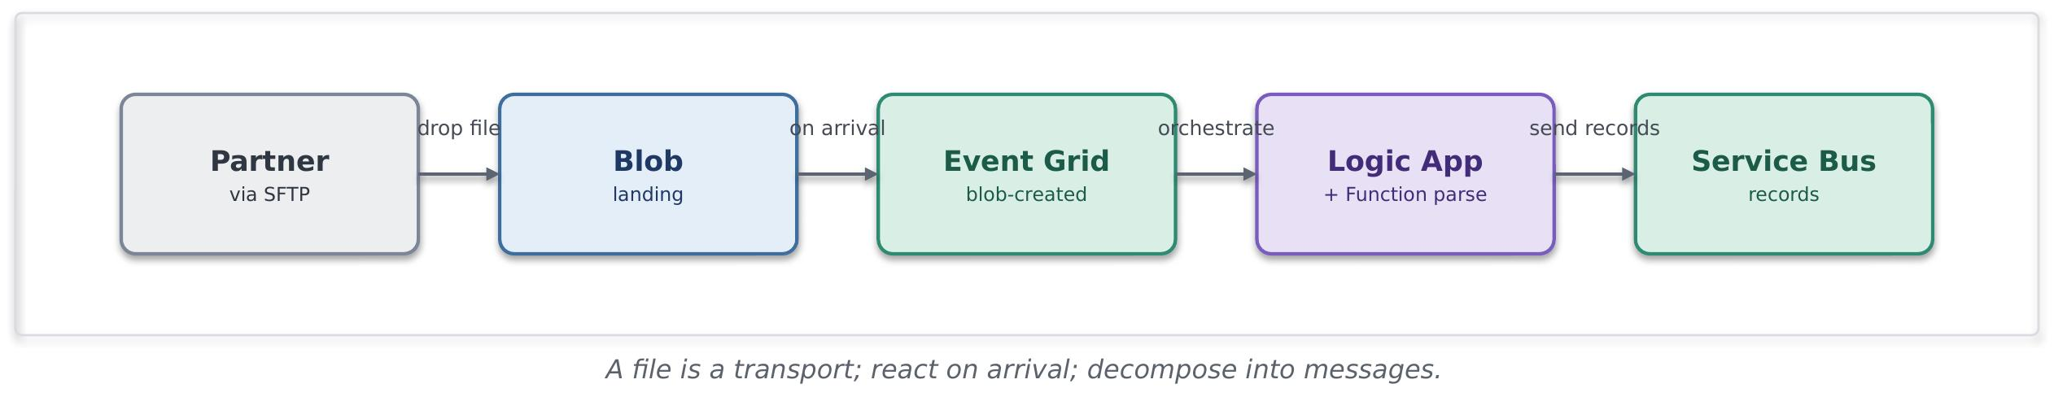
Problem. A source can exchange operational records only through files.
Solution. Land the file in approved storage, detect its arrival through Event Grid, validate it and distribute its records through messaging or orchestration.
When to use. A partner or legacy system can provide operational data only as a file.
When to avoid. An API or event is available, or the requirement is primarily analytical bulk ingestion.
Risks and considerations. Define completeness checks, validation, duplicate detection, replay, quarantine and retention.
Security boundary. Landing storage remains private. Partner SFTP uses approved authentication, encryption, source restrictions and boundary controls.
Common pitfall. Polling unnecessarily or treating the external file structure as a permanent internal contract.
In practice. A delegated-authority file is validated, translated and decomposed into messages for downstream processing.

File Generation and Delivery (SFINT20)
Generate and deliver a managed file to a consumer that requires file-based exchange. 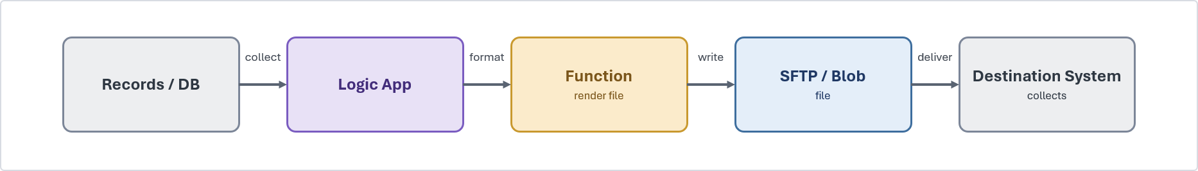
Problem. A partner, regulator or legacy system can consume data only in file form.
Solution. Generate the required file, stage it in approved storage and deliver it through the approved internal or external transfer route.
When to use. File delivery is contractually required, or the consumer cannot use APIs or events.
When to avoid. The consumer can use a governed API or event subscription.
Risks and considerations. Define file naming, schema versioning, encryption, retention, retry, delivery confirmation and reconciliation.
Security boundary. Staging remains private. External delivery uses controlled egress, approved SFTP authentication and centrally managed credentials.
Common pitfall. Using unmanaged scripts with embedded credentials and no delivery confirmation.
In practice. A settlement extract is generated and delivered to a partner SFTP endpoint with reconciliation evidence.

Transformation and Routing Patterns

Canonical Data Model and Message Translator (SFINT21)
Translate external and system-specific formats into a governed internal representation.
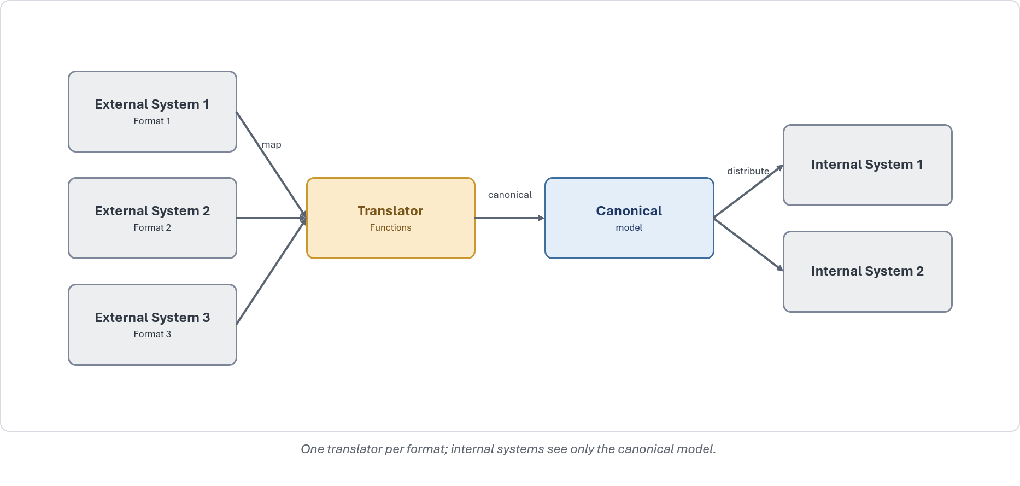
Problem. Systems and partners use different schemas, creating numerous point-to-point mappings and high change impact.
Solution. Define a canonical model for the business domain and translate messages at the integration boundary.
When to use. Several systems or external parties exchange the same business concepts using different formats.
When to avoid. Both parties use one stable schema, or only simple protocol conversion is required.
Risks and considerations. Canonical models require ownership, versioning, testing and controlled evolution.
Security boundary. Translation executes privately. External payloads must first pass through the applicable approved ingress pattern.
Common pitfall. Creating separate direct mappings between every source and destination.
In practice. Broker, cover-holder and market formats are translated into a common internal representation of risk, premium and claims data.

Content-Based Routing (SFINT22)
Route a message to the correct handler using validated message content or metadata.
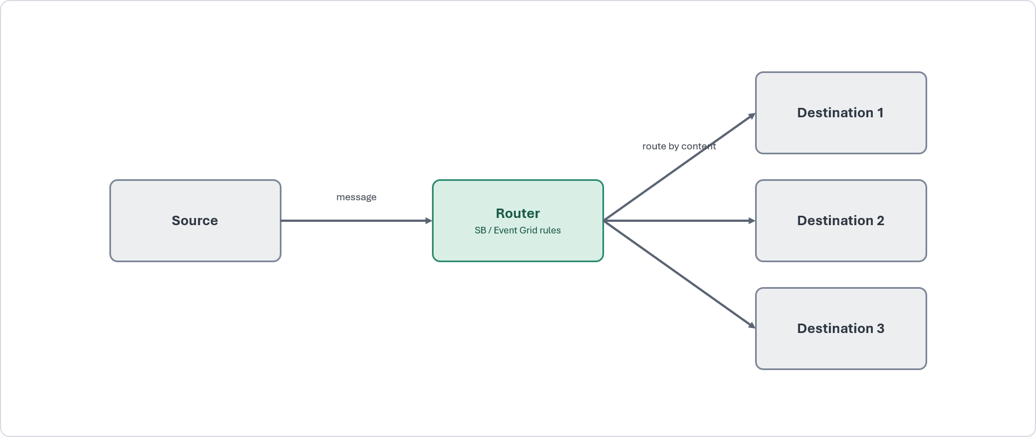
Problem. Messages arriving through a shared channel require different processing paths.
Solution. Apply Service Bus subscription filters, Event Grid routing or a bounded routing Function.
When to use. Messages can be assigned to destinations through stable, deterministic routing rules.
When to avoid. There is only one destination, or route selection requires a stateful business process.
Risks and considerations. Routing rules must be source-controlled, tested and monitored. Unmatched messages require an approved default or dead-letter route.
Security boundary. Routing components remain private and access to routing rules is restricted.
Common pitfall. Building a monolithic router with hard-coded destinations and no unmatched-message handling.
In practice. Submissions are routed to the appropriate processing path according to line of business, territory or submission type.

Data Platform Position

Core Position

The data platform is owned by the data team and is not a general integration endpoint.
The Systems Integration Framework interacts with the data platform through two governed hand-offs only: the ingestion of data into the platform and the consumption of curated data products from it.
Bulk movement and transformation remain inside the data platform. This boundary keeps operational integration and analytical data cleanly separated and governed.

Appropriate Uses

Landing operational data into the platform for analytics and reporting.
Serving a curated, read-only dataset back to an operational consumer through the platform's serving layer.
Streaming high-volume telemetry into the platform for downstream processing.

Inappropriate Uses

Treating Data Platform as an operational source of truth for live transactions.
Reaching into the platform's internals from an integration flow, or into operational systems from the platform.
Using the platform as a message bus or a general-purpose integration hub.

Exchange Patterns

Import Patterns

Event Streaming to the Data Platform (SFDEINT1)
Stream operational events into the data platform for near-real-time analytics without coupling producers directly to the platform..

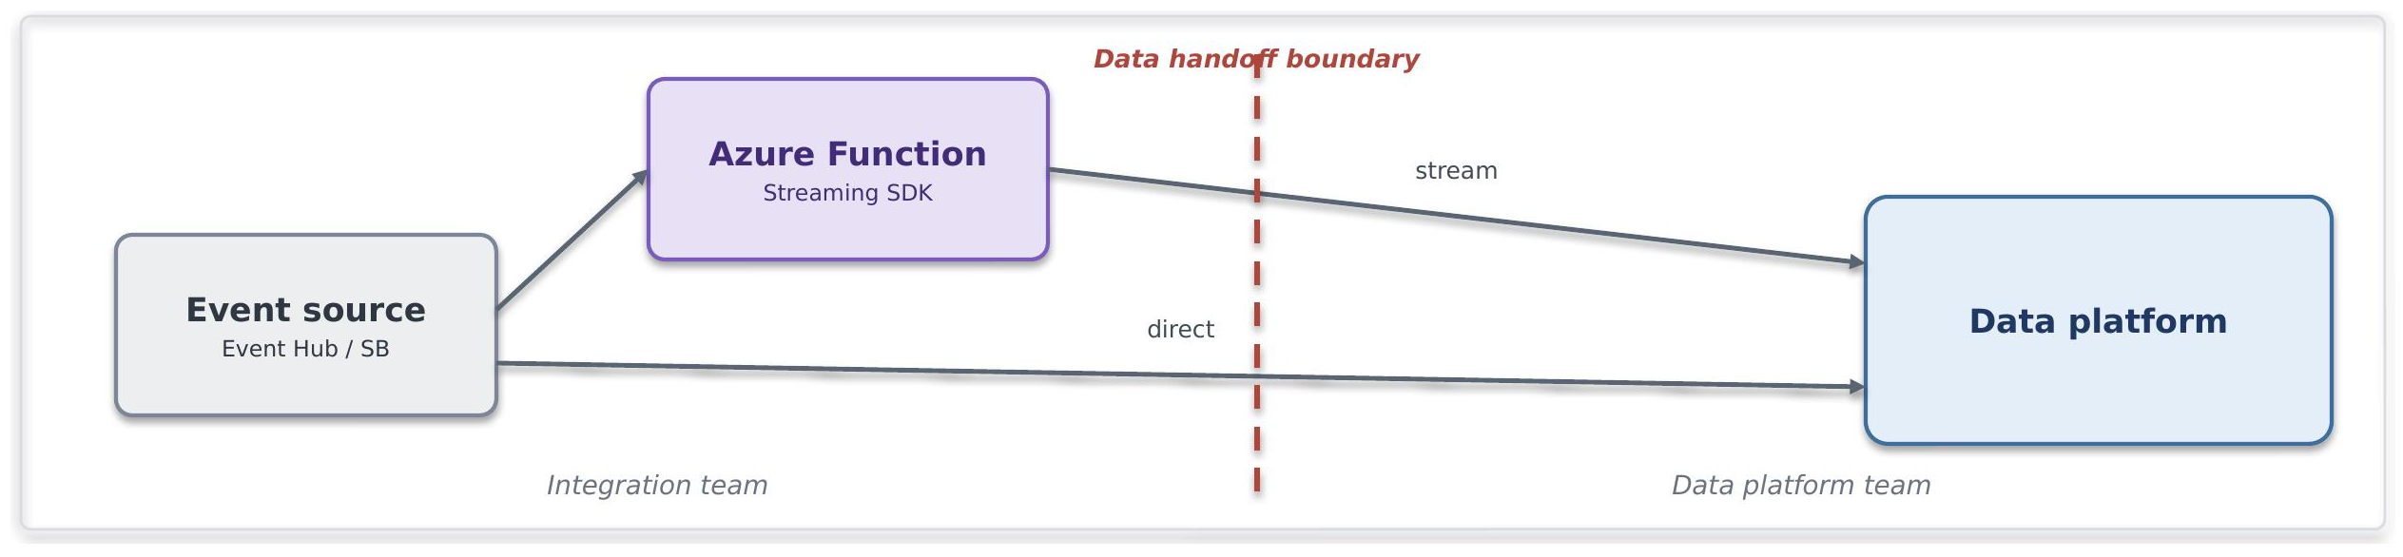

Problem. Events from Azure messaging or eventing services require continuous, low-latency ingestion into the data platform.
Solution. Trigger an Azure Function from Event Hubs, Service Bus or Event Grid. The Function batches events and submits them through the approved streaming-ingestion interface.
When to use. The source already publishes events through an approved Azure service, near-real-time ingestion is required, and custom ingestion logic is justified.
When to avoid. A managed connector meets the requirement, the source delivers files or the workload is better suited to managed high-volume ingestion.
Risks and considerations. Define batching, scaling, retries, checkpoints, duplicate handling, ordering and late-event treatment. The Function and its supporting code require named operational ownership.
Security boundary. The event source and Function use private connectivity and managed identity. Authentication to the data platform uses an approved key-pair, OAuth or equivalent mechanism. Account passwords must not be used.
Common pitfall. Writing individual rows for each invocation or failing to design for throughput, back-pressure and ingestion failure.
In practice. Telemetry is enriched by a Function and streamed into a raw data-platform schema for near-real-time exposure analysis.

File Ingestion (SFDEINT2)
Load files into the data platform automatically when they arrive in an approved landing zone.

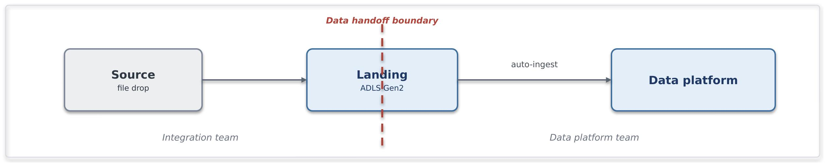
Problem. Sources deliver analytical data as files, and polling or custom loading processes create unnecessary complexity and operational risk.
Solution. Land each file in an approved ADLS Gen2 location. A storage event initiates the managed ingestion process, which loads the file into the appropriate raw schema.
When to use. Data arrives as discrete files, seconds-to-minutes latency is acceptable, and the producer can write to an approved landing zone.
When to avoid. Sub-second streaming is required, the workload is a single large scheduled load, or significant pre-load processing is required.
Risks and considerations. Govern file size, retention, replay and reconciliation. Excessive numbers of small files can increase processing cost.
Security boundary. The landing zone uses private connectivity with public access disabled. Producers write access and data-platform read access are separately scoped. Account keys must not be used.
Common pitfall. Treating the landing zone as a permanent storage or query layer.
In practice. Delegated-authority bordereaux land in a controlled path and are loaded into a raw schema for subsequent validation, conforming and reporting.

Scheduled Batch: CDC/ Watermark (SFDEINT3)
Extract new or changed operational data on a controlled schedule..

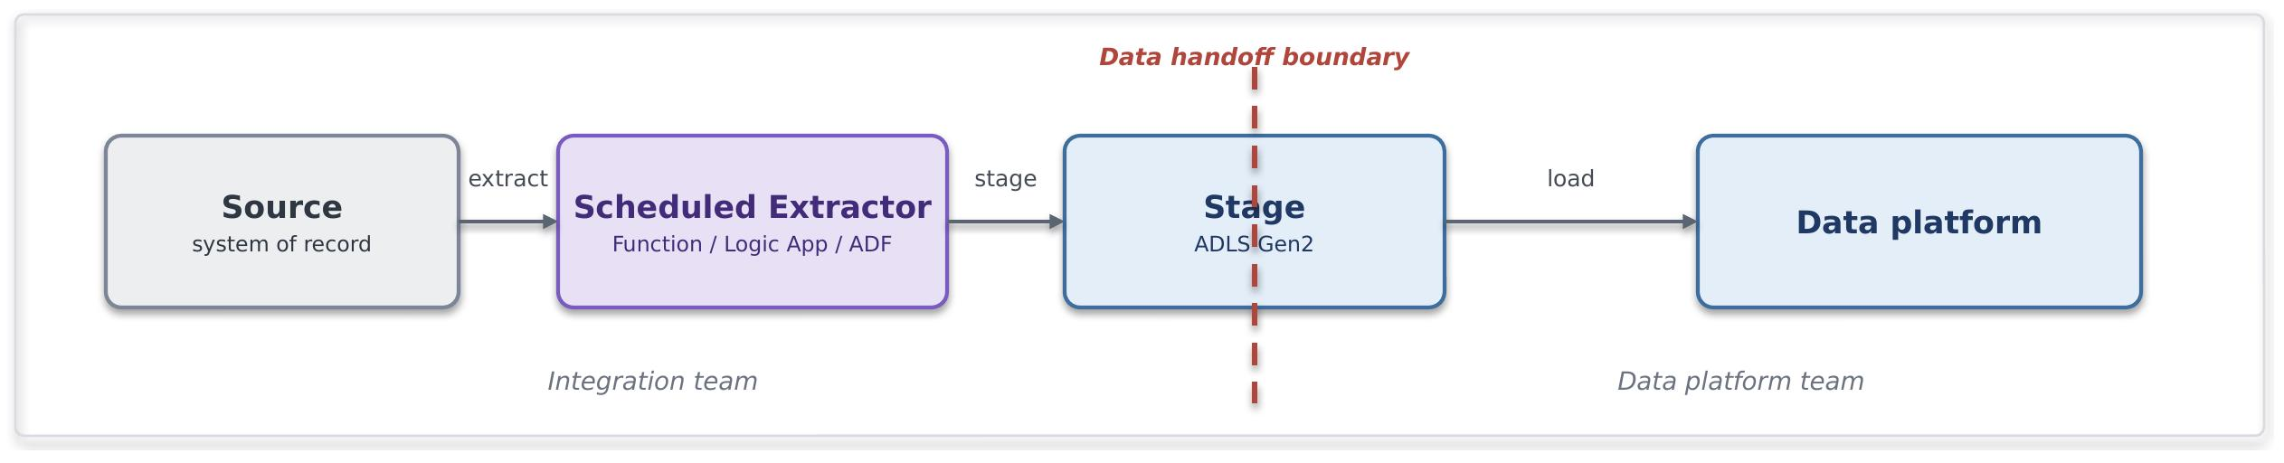

Problem. Data must be loaded incrementally from an operational source when near-real-time ingestion is unnecessary.
Solution. Use Azure Data Factory or an approved Function to extract records identified through change data capture or a reliable watermark. Stage the data in ADLS Gen2 and load it into the data platform.
When to use. The source provides a reliable change marker, scheduled delivery meets the business requirement, and data volumes favour batch processing.
When to avoid. Sub-minute latency is required, the source lacks a dependable change mechanism, or extraction would require repeated full scans.
Risks and considerations. Persist ingestion state and design for failure recovery without gaps or duplication. Address soft deletes, clock differences, source load windows and schema evolution.
Security boundary. Source and staging connections use approved private paths, managed identity where supported and least-privilege access. The data platform must not connect directly to the operational source.
Common pitfall. Advancing the watermark independently of a successful read or reverting to uncontrolled full reloads.
In practice. Policy and premium movements are extracted incrementally and loaded for finance and actuarial reporting.

Staged Multi Source Ingestion (SFDEINT4)
Coordinate ingestion from several sources and perform conforming within the data platform.

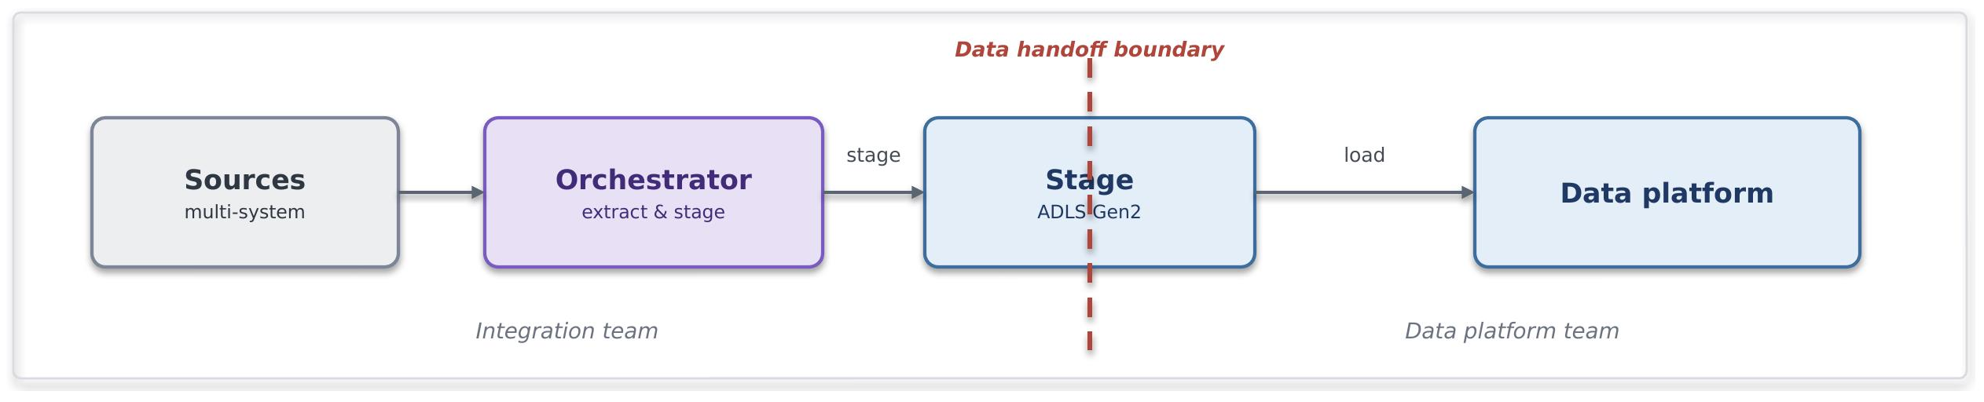

Problem. A governed data product requires data from multiple operational sources with coordinated loading and transformation.
Solution. Use Azure Data Factory to extract and stage source data independently. Load each feed into the data platform and perform conforming and transformation within the platform.
When to use. Several sources contribute to one analytical data product and their ingestion sequence or dependencies require coordination.
When to avoid. A single straightforward feed is sufficient, real-time processing is required, or data must be transformed or redacted before landing.
Risks and considerations. Design partial-failure recovery and reruns to be idempotent. Govern orchestration dependencies and data-platform transformation costs.
Security boundary. Each source uses a separate least-privilege identity. Staging uses private connectivity, and residual secrets are held through the approved secrets-management capability.
Common pitfall. Performing row-level transformation in the ingestion orchestrator instead of the data platform.
In practice. Claims, policy and reinsurance feeds are loaded separately and conformed into a governed claims data product.

Governed API Write (SFDEINT5)
Import a small, well-defined dataset through a governed API.

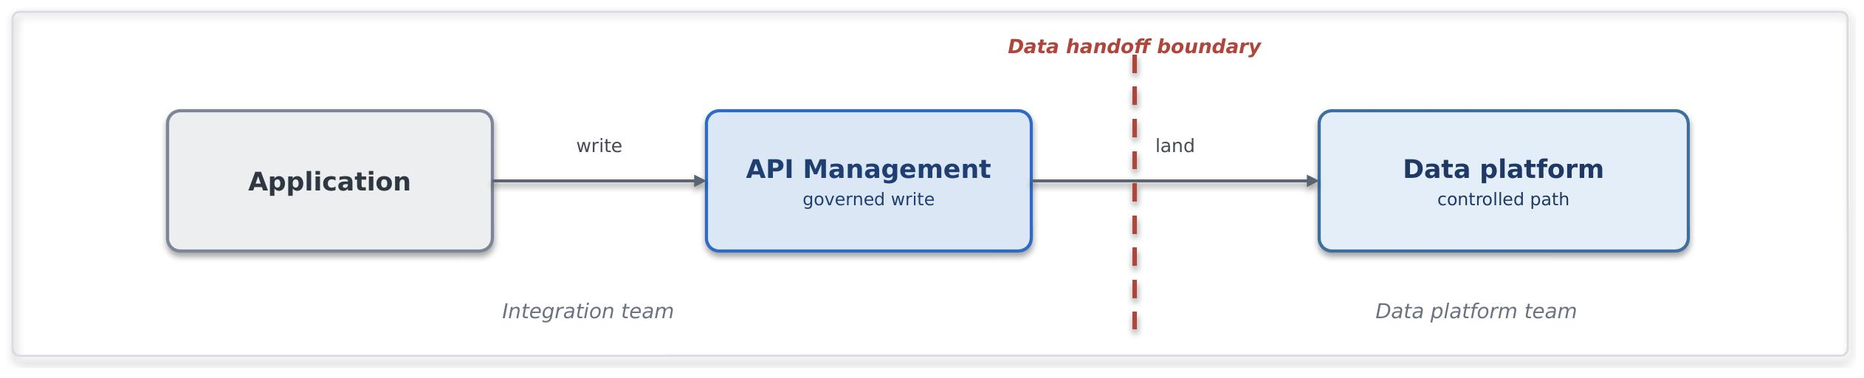

Problem. A consumer must submit low-volume data to the platform, but a file or streaming pipeline would be disproportionate.
Solution. Expose a controlled write operation through API Management. APIM authenticates and authorises the caller, validates and throttles the request, and invokes an approved platform procedure or API.
When to use. The write is small, well-defined and low-volume, and requires synchronous or near-synchronous handling.
When to avoid. Data is high-volume, variable in structure or supplied in bulk.
Risks and considerations. Define payload limits, throttling, idempotency, validation and transaction behaviour. The API must not become a general-purpose loading mechanism.
Security boundary. APIM is the integration boundary. Consumers have no direct platform access. The import path uses approved service identities and controlled procedures or APIs.
Common pitfall. Using a synchronous API for bulk or large-scale operational data loading.
In practice. An operations application submits a reference-data correction through APIM to a controlled platform procedure.

Export Patterns

Scheduled Data Export Pattern (SFDEINT6)
Publish a curated data product as a managed file for scheduled downstream consumption.

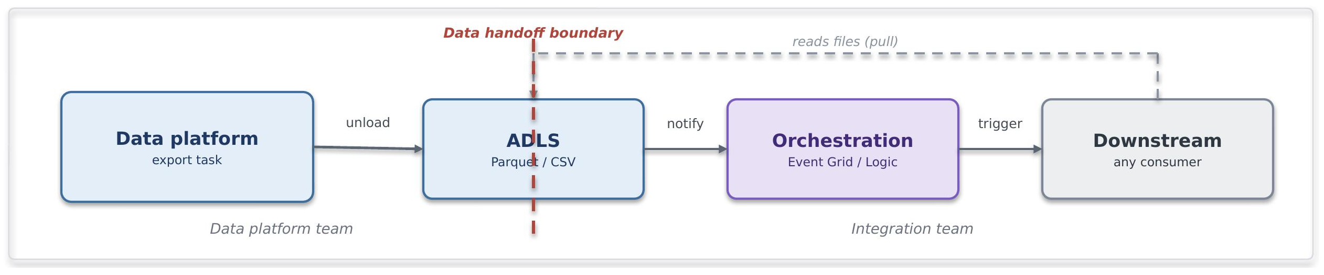

Problem. A downstream consumer requires a periodic curated dataset in file form without direct access to the data platform.
Solution. A scheduled platform task writes the curated dataset to an approved ADLS export path. Event Grid, Logic Apps or scheduled orchestration initiates downstream consumption.
When to use. The consumer processes files or batches, the exchange can follow a defined schedule, and the data platform must remain outside the operational processing path.
When to avoid. The consumer requires real-time access, needs only a small on-demand result or can use a governed API more effectively.
Risks and considerations. Coordinate publication and consumption schedules. Version the file schema and define retention, reconciliation and failure-recovery arrangements.
Security boundary. ADLS uses private connectivity. The platform service identity is restricted to the approved export path, and consumers receive read-only access to the required data. Consumers must not receive direct platform access.
Common pitfall. Exporting unnecessary data, failing to reconcile delivery and consumption or changing the schema without version control.
In practice. A curated claims dataset is exported to ADLS for scheduled consumption by an approved downstream analytical process.

Governed API Read (SFDEINT7)
Serve a small, curated analytical result through a governed API.
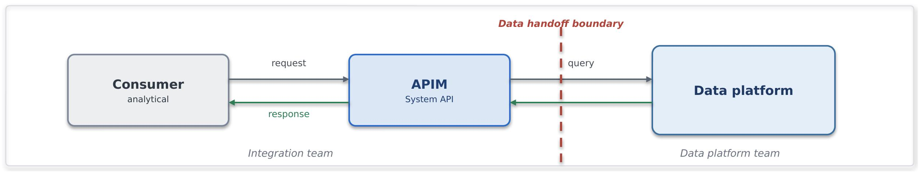
Problem. A consumer requires a specific analytical result on demand but must not receive direct access to the data platform.
Solution. Expose the curated result through API Management, backed by an approved serving or query layer. The data platform owns the data product and query logic; the integration platform owns API exposure and lifecycle controls.
When to use. The result is small, well-defined, synchronous and suitable for caching and rate control.
When to avoid. The consumer requires a large or complete dataset, transactional source data or a latency-sensitive operational response.
Risks and considerations. Define caching, throttling, availability and consumption expectations. Consumers must treat the result as curated and eventually consistent.
Security boundary. APIM authenticates and authorises the consumer. The serving layer uses an approved service identity, least-privilege access and private connectivity to the data platform.
Common pitfall. Using an analytical API for transactional processing or returning large datasets synchronously.
In practice. An internal application retrieves a governed analytical metric or lookup without connecting directly to the data platform.

Insurance Integration Scenarios

The table illustrates how the catalogue resolves characteristic Chaucer integrations. Each scenario names the patterns it composes, the primary Azure components and the purpose it serves. Pattern references point to the catalogue in Section 7.
Scenario | Patterns | Primary components | Purpose
Delegated Authority | File ingestion (SFINT19), canonical model (SFINT21), content routing (SFINT22), file ingestion to the data platform (SFDEINT2) | Logic Apps, Functions, Blob, Service Bus | Validate cover holder reporting, capture at source where possible, and retire manual bordereau re-keying.
London Market | Canonical model (SFINT21), messaging (SFINT8), orchestration (SFINT15), data platform exchange (8.4) | API Management, Logic Apps, Service Bus, Functions | Align processing to the core data record and design for incremental modernisation.
Submissions | Inbound webhook or API (SFINT1, SFINT12), file ingestion (SFINT19), content routing (SFINT22), composition (SFINT2) | API Management, Approved network edge service, Logic Apps, Functions | Accept submissions by API, file or portal, triage and route to the right underwriting team and system.
Claims | Inbound webhook or API (SFINT12), orchestration with compensation (SFINT15 and SFINT16), outbound webhook (SFINT13), data platform exchange (8.4) | API Management, Logic Apps, Service Bus, Functions | First notification of loss from portals and third-party administrators, orchestrated across systems, with status notifications outbound.
Reinsurance | Canonical model (SFINT21), file and messaging (SFINT20, SFINT8), orchestration (SFINT15) | Logic Apps, Functions, Service Bus | Cede risk, premium and claims to treaty and facultative systems and reinsurers and manage recoveries.
Regulatory Reporting | Event offload to the data platform (8.4), consume and serve (SFDEINT7), orchestration (SFINT15), file delivery (SFINT20) | Logic Apps, Functions, API Management | Assemble regulatory and tax reporting on the data platform and submit through orchestrated feeds or files.

Security and Operational Excellence

This section sets out the security and operational baseline every integration inherits by default. It states the outcomes the framework requires, while the mandatory rules and their enforcement sit in Sections 11 and 12. This section follows the Cloud Engineering Standards for the detail and does not restate or vary them.

Security Principles

The Systems Integration Framework adopts Chaucer's existing enterprise and cloud security principles and applies them consistently across integration solutions. Security controls are implemented according to the applicable enterprise and cloud standards, while the framework defines how those controls are applied within the integration domain.

Security area | What the Systems Integration Framework requires
Guiding principles  [Ref 1,8] | Private by default and least privilege, with zero trust across identity, network and data. The Systems Integration Framework states the security outcome, and the protection technology is chosen to meet it. Every design is secure by design and evidenced at the Technical Design Authority.
Connectivity  [Ref 1] | Integrations run on the private network over Private Endpoints, and the internet boundary is crossed only at a controlled edge.
Identity  [Ref 1,8] | Managed identity for service-to-service calls, so no credential is stored, and OAuth 2.0 tokens where a token is needed. External parties authenticate through Entra application registrations with short-lived tokens.
Secrets and certificates  [Ref 1] | Held in a managed store in Approved secret, key, and certificate management services and referenced at run time, never copied into configuration or code. Rotation and policy are handled through privileged access management. Long-lived shared access signatures are discouraged and recorded on the risk register where unavoidable.
Network isolation  [Ref 1,8] | Traffic is segmented east to west with network security groups and private connectivity, in line with the zero-trust direction, so a component is reachable only by the services that genuinely need it.
Access control  [Ref 1] | Least-privilege role-based access, with higher-risk permissions peer-reviewed and enforced through privileged identity management. An approved permission set is reused as a recognised pattern rather than reassessed from scratch.
Public exposure and edge  [Ref 1,8] | Public exposure is an exception, not a default. Private Endpoints and Private Link are preferred, and a firewall in front does not make a public endpoint acceptable. Any exposure needs a business need, security approval and escalation to the risk register, and the edge technology is chosen for the required outcome.

Data Protection and Classification

Chaucer's Data Classification Policy [Ref 2] sets six tiers in order of sensitivity, and the Systems Integration Framework applies the handling each tier requires as data crosses a boundary. Where a payload could meet more than one tier, the higher classification applies.

Classification | Risk | How the Systems Integration Framework handles it across a boundary
Sensitive Personal Data (special categories) | Very High | Minimised and pseudonymised or tokenised before it crosses a boundary. Processing is pre-approved by the Lead Data Protection Officer. Encrypted in transit and at rest, reached only over private connectivity, access logged, and never on a public path or in observability.
Personal Data | High | Minimised to what the integration needs, encrypted in transit and at rest, reached over private connectivity with least-privilege access, pseudonymised or tokenised before analytics, and kept out of logs and traces.
Restricted Commercial | Medium High | Encrypted in transit and at rest, reached over private connectivity with access restricted and audited, and not exposed externally except as an approved exception.
Commercial | Medium | Encrypted in transit and at rest on the private network, with standard least-privilege access.
Internal | Low | The default classification. Encrypted in transit and at rest, kept on the private network and not exposed externally.
Public | None | May be served externally through the governed edge as an exception, still over TLS and through the gateway.

Observability and Monitoring

Operational monitoring uses Application Insights, LogicMonitor and Log Analytics, with dashboards and alerts for delivery and issue resolution.
Security monitoring is satisfied separately from operational monitoring. Relevant security events, for example Key Vault/Cyber Ark activity, deployment and administrative actions, are forwarded to CrowdStrike, the Group Security tooling, and any new gateway or edge component is assessed for security-event capture before it goes live.
An established pattern already streams Azure, Key Vault/ Cyber Ark, storage and security logs to CrowdStrike through Event Hubs, and the Systems Integration Framework reuses that path rather than inventing a new one.

Azure Resource Observability Matrix

Resource | Operational signal | Security signal | Destination
Azure API Management | Latency, throughput, failures, Backend Response Times | Authentication Failures, Authorization Failures, Policy Violations | Log Analytics, CrowdStrike
Azure Logic Apps | Run Success/Failure, Duration, Retries | Connection Events, Managed Identity Usage, Authentication Failures | Log Analytics, CrowdStrike
Azure Service Bus | Queue Depth, Dead-Letters, Message Age, Throttling | Access and Authorization Events | Log Analytics, CrowdStrike
Azure Event Grid | Delivery Success/Failure, Retry Activity, Subscription Health | Topic and Subscription Access Events | Log Analytics, CrowdStrike
Azure Event Hubs | Throughput, Consumer Lag, Throttling | Namespace Access and Authorization Events | Log Analytics, CrowdStrike
Azure Functions | Executions, Errors, Duration, Scaling Events | Managed Identity Usage, Key Vault Access, Authentication Failures | Log Analytics, CrowdStrike
Azure Data Factory | Pipeline Success/Failure, Activity Duration, Trigger Failures, Integration Runtime Health | Managed Identity Usage, Linked-Service Access, Authentication Failures | Log Analytics, CrowdStrike

Operational Excellence

The discipline that keeps an integration secure also keeps it operable.
Deployed as code. Integrations are provisioned through infrastructure-as-code and delivered through DevSecOps pipelines, so an environment is reproducible and reviewable, and nothing is configured by hand.
Resilience matched to criticality. The redundancy and recovery posture of an integration follows its criticality tier, set with business continuity and risk and evidenced at design time
Owned and kept live. Each integration has monitoring, alerting and a defined support model with named ownership, and the Systems Integration Framework itself is maintained as a live artefact, reviewed continuously rather than only before a Technical Design Authority submission.

Delivery Pipeline

Every integration is delivered through a single pipeline, and the pipeline is where quality, security and controlled promotion are enforced. This applies the automation and DevSecOps direction inherited from the Cloud Engineering Standards to integration delivery and sets out the agreed practice every integration follows so that nothing reaches an environment by hand.
Source: [Ref 3]

Practice | What the pipeline does
Pipeline foundation | Source code and infrastructure-as-code live in the Chaucer repository and every change is built and deployed through the pipeline. The pipeline is the only route to an environment.
Pull-request validation | Every change enters through a pull request. The pipeline builds it, lints it, runs its automated tests and its security scans, and the change cannot merge until those checks pass and a peer has approved the request.
Immutable artefacts | A versioned artefact is built once and promoted unchanged through every environment. Nothing is rebuilt per environment, so what runs in production is exactly what was tested.
Deploy to development first | A merged change deploys automatically to development, where it runs against real dependencies. Development is where integration behaviour is proven before anything is promoted.
Integration and automation testing | Automated unit, integration, and end-to-end testing should be implemented wherever feasible within the delivery pipeline, including relevant contract and schema validations. Changes should only progress once the applicable automated and manual quality checks have been successfully completed.
Environment validation checks | Configuration, connectivity, identity, secrets, and health checks should be automated before and after deployment wherever feasible. Where automation is not practical, appropriate validation controls are applied to ensure an environment is proven ready rather than assumed to be.
Security testing | Static analysis through SonarQube checks code quality and known weaknesses, and artefact and dependency scanning through JFrog checks the build and its libraries. Issues block deployment, in line with the security testing the Cloud Engineering Standards require.
Controlled promotion | Promotion from development to test to UAT and on to production is gated and approved. A higher environment accepts only an artefact whose checks have passed and whose sign-off is recorded, and production promotion follows change control.
DAST coverage | DAST coverage will be included in the delivery pipeline once this capability is established in Chaucer.

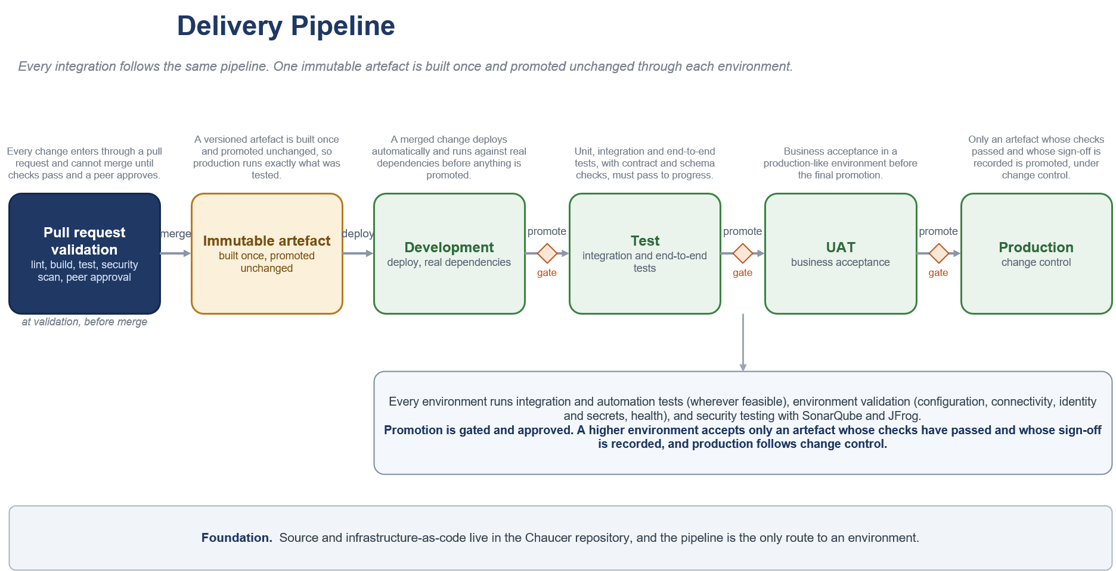

Guardrails

Mandatory Guardrails

Regardless of patterns being used, every integration design must adhere to security principles and engineering standards. [Ref 1,4,5]

Per-Pattern Security Conformance

Purpose
Every selected integration pattern must be assessed against the security baseline defined in Section 10 and the mandatory guardrails in Section 11.1.
The detailed pattern catalogue defines a security boundary for each pattern. This section consolidates those requirements into a single conformance matrix so that an architecture review can confirm:
- The pattern and boundary being used.
- Whether an internet or third-party boundary is crossed.
- The applicable identity and authentication controls.
- The required connectivity and network controls.
- The required secrets and certificate controls.
- The pattern-specific security considerations.
- The suitability of the pattern for the classification of data being handled
- Whether standard conformance is possible or an exception is required.
The security baseline is:
- Private connectivity by default.
- Managed identity for Azure service-to-service authentication wherever supported.
- Least-privilege RBAC.
- Approved secret, key, and certificate management services.
- TLS for every network hop.
- Public exposure only through an approved network edge and API Management where applicable.
- No direct exposure of Functions, Logic App HTTP triggers, backend APIs or internal service endpoints.
- Data minimisation and handling according to the applicable data classification.
- Security and administrative events forwarded through the approved security-monitoring route.
- Formal exception approval where the baseline cannot be met.
These controls consolidate the identity, connectivity, secrets, access-control and public-exposure requirements already defined in Section 10.1.

Conformance Classifications

Classification | Meaning
Standard | The pattern can normally operate within the approved private security baseline.
Standard with boundary controls | The pattern crosses a controlled system, data or organisational boundary and requires the additional controls listed in this section.
Exception required | The proposed implementation cannot meet the standard baseline, introduces public exposure, uses unsupported authentication or connectivity, or bypasses an approved platform control.
Not applicable | The pattern is not appropriate for the proposed boundary or use case.

A pattern identified as Standard with boundary controls does not automatically require an exception. An exception is required only where the implementation cannot satisfy the specified boundary controls or otherwise deviates from the framework.

Integration Pattern Conformance
API and request-response patterns

Pattern | Normal security classification | Required security conformance | Exception triggers
SFINT1 Managed API Facade, internal | Standard | APIM must remain non-public. Consumer-to-APIM and APIM-to-backend communication must use approved private connectivity and TLS. APIM must authenticate to the backend using managed identity wherever supported. The consumer must be authenticated and authorised through the approved identity model. | Direct backend exposure, public APIM endpoint, public backend endpoint, stored credentials where managed identity is supported, bypassing APIM.
SFINT1 Managed API Facade, external | Standard with boundary controls | An approved network edge must terminate the public endpoint. APIM must remain behind the edge and must not be exposed directly. OAuth, OIDC, mTLS or another approved authentication mechanism must be applied. Rate limiting, request validation, monitoring and backend isolation must be implemented. | Direct public APIM exposure; direct Function, Logic App or backend exposure, missing edge protection, unsupported authentication, unregistered public exposure.
SFINT2 API Composition and Aggregation | Standard | APIM and the composition service must remain private. The composition service must use managed identities and least-privilege access for each backend. Per-backend timeout and failure handling must be defined. Sensitive data must be minimised in the aggregated response. | Public composition Function; shared credentials across backends, excessive data aggregation; composition bypassing APIM.
SFINT3 Protocol and Format Mediation | Standard, or standard with boundary controls for external partners | APIM or the mediation Function must remain inside the approved integration boundary. Connectivity to Azure or on premises backends must use approved private paths. Schema validation must be applied before forwarding malformed or untrusted payloads. | Internet-exposed mediator, credentials in transformation code, business logic embedded in gateway policy, internet-only legacy connection without approved boundary controls.

Messaging patterns
Pattern | Normal security classification | Required security conformance | Exception triggers
SFINT4 Queue-Based Load Levelling | Standard | Producers and consumers must access Service Bus through approved private connectivity. Managed identity and separate Sender and Receiver RBAC roles must be used. External producers must enter through an approved ingress pattern rather than connect directly to Service Bus. | Public Service Bus access; SAS keys where managed identity is supported, an external producer connecting directly to the namespace, shared sender and receiver identities.
SFINT5 Competing Consumers | Standard | Service Bus and workers must remain private. Each consumer workload must use least-privilege Receiver permissions. Consumer identities and processing activity must be traceable. | Public queue access; shared high-privilege identities, credentials embedded in worker configuration.
SFINT6 Asynchronous Request-Reply, internal | Standard | Request, status and callback components must use private connectivity, managed identity and TLS. Correlation IDs must not contain secret or sensitive information. Access to status data must be authorised. | Public status store, sensitive information embedded in correlation IDs, unauthorised access to another caller’s result.
SFINT6 Asynchronous Request-Reply, external | Standard with boundary controls | Request and status endpoints must be exposed through the approved edge and APIM. The same identity and authorisation model must protect request submission and result retrieval. Callback endpoints must use an approved outbound or webhook pattern. | Direct public Function or Logic App endpoint, predictable or unauthorised status URLs, callback credentials outside Key Vault.
SFINT7 Claim-Check | Standard | Blob Storage and Service Bus must remain private. Blob access must use managed identity and RBAC. Public access, account keys and public or long-lived SAS URLs must not be used. Payload retention and reference expiry must be aligned. | Public blob access, long-lived SAS references, account keys, payload retained beyond the approved period, message references accessible by unauthorised consumers.
SFINT8 Reliable Messaging | Standard | Service Bus access must use managed identity, least-privilege RBAC, private connectivity and TLS. Idempotency keys must not contain secrets. Dead-letter access must be restricted and monitored because dead-lettered messages may contain business data. | Public access, SAS-based application access where managed identity is supported, unprotected dead-letter data, secrets in message metadata.
SFINT9 Scheduled or Timed Trigger | Standard, or standard with boundary controls for external egress | The scheduler must run inside an approved workload boundary and use managed identity for downstream calls. Configuration and schedules must be source-controlled. Any external delivery must use the relevant approved outbound API or file-transfer controls. | Credentials embedded in schedules, public unauthenticated triggers, uncontrolled default internet egress, scheduled process bypassing the approved integration platform.
Eventing and streaming patterns
Pattern | Normal security classification | Required security conformance | Exception triggers
SFINT10 Publish-Subscribe Fan-Out | Standard | Service Bus Topics and subscriptions must remain private. Publisher and subscribers must use separate least-privilege identities. Each subscriber must be limited to its own subscription where practicable. Dead-letter queues must be access-controlled and monitored. | Subscriber access to unrelated subscriptions, shared high-privilege identities, public namespace access, unauthorised subscription creation.
SFINT11 Discrete Event Notification | Standard | Event Grid and Azure-native handlers must use private connectivity where supported, managed-identity delivery and handler-side validation. Events must contain the minimum data needed and must not become an uncontrolled copy of the source record. | Internet-reachable handler treated as an internal Event Grid pattern, sensitive records included unnecessarily in events, unauthenticated handlers.
SFINT12 Inbound Webhook Ingestion | Standard with boundary controls | An approved network edge must terminate the public endpoint. APIM must provide the API ingress. Authentication must use mTLS, OAuth, signed-payload validation or another approved mechanism. Rate limiting, replay protection, deduplication and request validation must be implemented. Downstream processing must occur asynchronously within private workload boundaries. | Direct public Function or Logic App trigger, direct APIM exposure, no replay protection, no caller authentication, synchronous processing of untrusted requests, public exposure not recorded and approved.
SFINT13 Outbound Webhook or Notification | Standard with boundary controls | Traffic must leave through the approved controlled egress route. TLS must be enforced. Partner endpoints should be allow-listed where applicable. Authentication material must be held in Approved secret, key, and certificate management services. Payload signing, retry, circuit breaking and delivery auditing must be used where supported and required. | Default internet routing, secrets in configuration, unsigned sensitive payload where signing is required, uncontrolled subscriber registration, unrestricted destination endpoints.
SFINT14 Stream and Telemetry Ingestion, internal | Standard | Event Hubs, processors and capture storage must use approved private connectivity, managed identities, RBAC and TLS. Producer and consumer-group permissions must be separated. Capture storage must have public access disabled. | Public Event Hubs access, shared access keys for workload code where managed identity is supported, public capture storage, unrestricted consumer-group access.
SFINT14 Stream and Telemetry Ingestion, external feed | Standard with boundary controls | The external feed must enter through an approved boundary mechanism. Authentication, source validation, throughput controls and monitoring must be defined. Internal Event Hubs and processors must remain private. | External producer connecting through an uncontrolled public namespace, unauthenticated feed, missing source validation or capacity protection.
Orchestration patterns
Pattern | Normal security classification | Required security conformance | Exception triggers
SFINT15 Stateful Process Orchestration | Standard | The orchestrator must run inside the private workload boundary. Connections to APIM, Functions, Service Bus and other services must use managed identities and approved private connectivity. Secrets must be referenced from Approved secret, key, and certificate management services. External initiation must enter through an approved ingress pattern. | Direct external invocation of the workflow, embedded connection secrets, excessive permissions across participating systems, public orchestration endpoints.
SFINT16 Process with Compensation | Standard | The orchestrator and compensation components must use the controls for SFINT15. Access to compensation operations must be restricted because they can reverse or modify completed business actions. Execution and compensation history must be auditable. | Unauthorised manual invocation of compensation, compensation credentials stored in code, missing audit trail, broad write access across systems.
SFINT17 Human-in-the-Loop Approval | Standard | Approval interactions must use approved, identity-authenticated channels. The approver identity, decision and time of decision must be auditable. Approval links must not provide unauthenticated or transferable authority. | Anonymous approval, approval through an untracked external email process, shared approver identity, decision data exposed publicly.
SFINT18 Scatter-Gather | Standard, or standard with boundary controls where external services participate | The orchestrator and internal workers must remain private and use managed identity and least-privilege access. External calls must follow the applicable approved egress pattern. Responses must be validated before aggregation. | Public worker endpoints, single broad identity across all workers, unvalidated external responses, external services called through default internet routing.

File, transformation and routing patterns
Pattern | Normal security classification | Required security conformance | Exception triggers
SFINT19 Event-Driven File Ingestion, internal | Standard | Landing storage must have public access disabled and use private connectivity, managed identity, RBAC and TLS. File validation, isolation of invalid files, retention and replay controls must be implemented. | Public storage, account keys, unvalidated processing, unrestricted landing-zone access.
SFINT19 Event-Driven File Ingestion, partner SFTP | Standard with boundary controls | SFTP must use SSH with key or certificate authentication. Anonymous access must be disabled. Source restrictions, encryption, malware scanning where required, file validation and reconciliation must be implemented. Internet-facing SFTP must follow the approved exception process. | Password-only or anonymous SFTP, public storage behind the SFTP endpoint, no file validation, unregistered internet exposure.
SFINT20 File Generation and Delivery, internal | Standard | Files must be generated and staged in private storage. Managed identity and RBAC must be used. Access must be limited to the intended consumer, and retention and delivery confirmation must be defined. | Public collection path; shared account key, unrestricted access to generated files.
SFINT20 File Generation and Delivery, external | Standard with boundary controls | External SFTP delivery must use SSH key or certificate authentication, destination allow-listing, controlled egress and Key Vault/Cyber Ark-held credentials. Sensitive files must be signed or encrypted where required. Delivery confirmation and reconciliation must be retained. | Credentials in configuration, default internet routing, unencrypted sensitive file, delivery to an unapproved destination, no delivery reconciliation.
SFINT21 Canonical Data Model and Message Translator | Standard | Translation components must remain private and use managed identity and TLS. Incoming payloads must arrive through the applicable boundary pattern. Schema validation and data minimisation must occur before internal distribution. | Internet-exposed translator, unaudited mappings of sensitive data, credentials embedded in transformation code; bypassing the relevant ingress pattern.
SFINT22 Content-Based Routing | Standard | Routing components and rules must remain private, source-controlled and access-restricted. Unmatched messages must be sent to an approved default or dead-letter path. Routing decisions must not expose data to unauthorised destinations. | Dynamically supplied unrestricted destinations, missing default route, unauthorised modification of routing rules, routing based on unvalidated data.

Data Pattern Conformance
The data platform is a governed analytical boundary. Security controls for approved data-platform exchange patterns are defined below.
Pattern | Normal security classification | Required security conformance | Exception triggers
SFDEINT1 Event Streaming to the Data Platform | Standard with data-platform boundary controls | The Azure event source and Function must use private connectivity and managed identity. Data Platform authentication must use an approved key-pair, OAuth or equivalent approved mechanism, with applicable secrets in the approved vault. Account passwords must not be used. | Account-password authentication, secrets embedded in Function configuration, public event-source direct access to Data Platform
SFDEINT2 File Ingestion | Standard with data-platform boundary controls | The ADLS landing zone must have public access disabled and use private connectivity. Producers write access and read access for the Data Platform must be separately scoped. Data Platform must authenticate through an approved storage integration or service identity rather than account keys. | Public landing zone, account keys; producer read access where not required, Data Platform access beyond the approved landing path.
SFDEINT3 Scheduled CDC or Watermark Ingestion | Standard with data-platform boundary controls | Source connectivity and staging must use approved private paths. Managed identity must be used wherever supported. Any residual secrets must be held in the approved vault. Data Platform must not require direct access to the operational source. | Data Platform direct access to the operational system, embedded source credentials; public staging, broad source-system permissions.
SFDEINT4 Staged Multi-Source Ingestion | Standard with data-platform boundary controls | Each source connection must use a separate least-privilege identity. Managed identity must be used wherever supported. Remaining secrets must be stored in the approved vault. Staging must use private connectivity, and transformation must remain within Data Platform where the pattern specifies ELT. | One unrestricted identity for all source systems, public staging, row-level sensitive transformation on uncontrolled intermediate compute, secrets in the pipeline definition.
SFDEINT5 Governed API Write | Standard with API and data-platform boundary controls | APIM must enforce authentication, authorisation, validation, throttling and access policy. Consumers must not receive direct Data Platform access. The Data Platform import path must use approved service identities and controlled procedures or APIs. | Direct consumer connection to Data Platform, bulk loading through the synchronous API, unauthorised procedure invocation, public backend bypassing APIM.
SFDEINT6 Scheduled Data Export | Standard with file-exchange and data-platform boundary controls | ADLS must use private connectivity. The Data Platform service identity must be restricted to the designated export path. Downstream consumers must receive read-only access to the required path only. Sensitive exports must follow applicable encryption, retention and external-delivery controls. | Direct downstream access to Data Platform, public export storage, consumer write access, unencrypted sensitive external export, unrestricted export path.
SFDEINT7 Governed API Read | Standard with API and data-platform boundary controls | APIM must authenticate and authorise consumers and apply caching, throttling and access policy. The approved serving or query identity must have least-privilege access. The response must contain only the defined curated result. | Direct Data Platform credentials supplied to consumers, bulk extraction through the API, transactional use of analytical results, public backend exposure.

Governance

Every integration design must be approved at the TDA and should evidence the profile, pattern and security conformation as described in the subsequent sections.

Profile and Pattern Conformance Evidence

Every integration design must record the selected Enterprise Integration Profile and Detailed Integration Patterns. The minimum pattern-selection record is:

Required information | Required Information / Evidence
Business Requirement | Business capability, process, use case, expected outcome, business owner and consuming systems.
Enterprise Integration Profile | Selected Enterprise Integration Profile (SIF-Pnn), profile name and integration domain.
Detailed Practitioner Pattern | Selected SFINTnn/SFDEINTnn patterns, decision-tree outcome, boundary crossed and rationale.
Primary Platform Capabilities | Approved platform services used to implement the solution.
Boundary & Connectivity | Integration boundary, private endpoints, routing, ingress/egress paths and network controls.
Data Classification & Data Handling | Classification, data exchanged, minimization, encryption, retention and logging restrictions.
Identity & Access Management | Caller, workload and backend identities, authentication, authorization, RBAC and permissions.
Secrets & Certificate Management | Secret storage, ownership, lifecycle, rotation and monitoring.
API & Webhook Controls | Authentication, validation, throttling, replay protection, edge controls and versioning.
Messaging Controls | Permissions, idempotency, retry, dead-letter handling, ordering and retention.
File Transfer Controls | Landing/export paths, access permissions, encryption, validation, reconciliation and retention.
Data Platform Controls | Service roles, schemas, procedures, ownership and access restrictions.
Operational Controls | Monitoring, logging, alerting, ownership, support model, runbooks and SLAs.
Reliability & Resilience | Availability, backup, recovery, DR, retry strategy and resiliency design.
Mandatory Guardrail Compliance | Evidence is that engineering standards, security controls and platform guardrails are satisfied.
Exceptions & Risks | Exception reference, compensating controls, owner, approval, expiry and remediation plan.
Design Approval | Architecture, security and business approvals, dates and implementation status.

A design must not record only a technology choice such as "Logic Apps", "Service Bus" or "Functions". The selected technology must be linked to an approved Enterprise Integration Profile and one or more Detailed Integration Patterns, supported by the corresponding security, operational and governance evidence

Selection Example

- Business Requirement: A third-party payment provider must notify Chaucer when a settlement event occurs.
- Enterprise Integration Profile: SIF-P11 Third-Party Webhook Ingress.
- Detailed Practitioner Pattern: SFINT12 Inbound Webhook Ingestion.
- Primary Platform Capabilities: Approved Network Edge, API Management, Service Bus and Azure Functions.
- Boundary & Connectivity: Third Party to Chaucer through approved ingress controls and private downstream processing.
- Data Classification & Data Handling: Commercial data, encrypted in transit, subject to retention and logging controls.
- Identity & Access Management: OAuth/mTLS authentication, managed identities and least-privilege RBAC.
- Secrets & Certificate Management: Certificates and secrets managed through the approved enterprise secrets-management capability.
- API & Webhook Controls: Payload validation, replay protection, throttling, rate limiting and API versioning.
- Messaging Controls: Durable queue handling, retry policies and dead-letter management.
- File Transfer Controls: Not applicable.
- Data Platform Controls: Not applicable.
- Operational Controls: Monitoring, alerting, audit logging, support ownership and runbook coverage.
- Reliability & Resilience: Retry handling, dead-letter processing and recovery procedures defined.
- Mandatory Guardrail Compliance: Security, connectivity and platform guardrails satisfied.
- Exceptions & Risks: None.
- Design Approval: Architecture, Security and Business approvals obtained.

Composite-Pattern Example

- Business Requirement: A delegated-authority bordereau is received as a file, translated to Chaucer's internal model, validated across several systems and delivered reliably to the policy platform.
- Enterprise Integration Profiles: SIF-P12 Managed File Exchange, SIF-P14 Specialist Mediation and Transformation, SIF-P09 Workflow Orchestration and SIF-P05 Reliable Queue Messaging.
- Detailed Practitioner Patterns: SFINT19 Event-Driven File Ingestion, SFINT21 Canonical Data Model and Message Translator, SFINT15 Stateful Process Orchestration and SFINT08 Reliable Messaging.
- Primary Platform Capabilities: Blob Storage, Event Grid, Functions, Logic Apps and Service Bus.
- Boundary & Connectivity: Third Party to Chaucer through managed file ingress and private internal processing.
- Data Classification & Data Handling: Restricted Commercial data with approved handling, validation, retention and audit controls.
- Identity & Access Management: Managed identities, least-privilege RBAC and approved service-to-service authentication.
- Secrets & Certificate Management: Secrets and certificates managed through the approved enterprise secrets-management capability.
- API & Webhook Controls: Not applicable.
- Messaging Controls: Queue permissions, idempotent processing, retry policies, dead-letter handling and message retention controls.
- File Transfer Controls: Controlled landing zone, validation, reconciliation, retention and access controls.
- Data Platform Controls: Not applicable.
- Operational Controls: Monitoring, alerting, support ownership, runbooks and recovery procedures.
- Reliability & Resilience: Guaranteed delivery, replay capability and recovery controls documented.
- Mandatory Guardrail Compliance: Security, connectivity, monitoring and deployment guardrails satisfied.
- Exceptions & Risks: None.
- Design Approval: Architecture, Security and Business approvals obtained.

Where several profiles or patterns are combined, each profile and pattern must be listed separately. Combining patterns does not create a new pattern identifier.

Security Conformance

Standard private patterns proceed on the agreed security baseline. A pattern that cannot meet the baseline triggers the exception process, which requires a security review prior to TDA. Where the wider security posture is affected, the exception is escalated to the risk register and senior leadership and managed via ERM framework. The integration design document must explicitly document per pattern security conformance as specified in section 11.2

Exceptions

The Systems Integration Framework is principles-driven but pragmatic. Where a justified need exists to deviate from an approved pattern, guardrail, or architectural boundary, the exception must be formally documented, risk-assessed, assigned an owner, and reviewed periodically. Appropriate compensating controls must be implemented, with a defined path and timeline to return to the standard approach where practical.

Glossary

Term | Meaning
SIF | Systems Integration Framework, this document.
AIS | Azure Integration Services, comprising API Management, Logic Apps, Service Bus, Event Grid, Event Hubs and Functions.
SOA | Service-oriented architecture, coarse-grained services aligned to business capabilities.
APIM | Azure API Management.
Managed identity | An Entra identity for an Azure resource that authenticates without stored secrets.
Claim-check | A pattern that keeps a large payload in storage and passes a reference on the message.
Idempotency | The property that applying the same message more than once has no additional effect.
Bordereau | A delegated-authority premium or claims report provided by a cover holder.
TDA | Technical Design Authority.
ADF | Azure Data Factory.
ADLS | Azure Data Lake Storage.
HLSA | High Level Solution Architecture.
SME | Subject Matter Expert.
RBAC | Role-Based Access Control.
NSG | Network Security Group.
OAuth | Open Authorization framework used for delegated access to protected resources.
OIDC | OpenID Connect; an authentication protocol built on OAuth 2.0.
mTLS | Mutual Transport Layer Security, where both client and server authenticate each other.
TLS | Transport Layer Security, the standard protocol for encrypting network communications.
CDC | Change Data Capture, a technique for identifying and processing data changes incrementally.
DLQ | Dead Letter Queue, a queue used to hold messages that cannot be processed successfully.
ELT | Extract, Load, Transform.
ETL | Extract, Transform, Load.
SDK | Software Development Kit.
Correlation ID | A unique identifier used to trace a transaction or message across multiple systems and services.
ACORD | Insurance industry standards organisation providing standardised data models and message formats.
CDR | Core Data Record, the London Market standard for structured insurance data exchange.
DLRM | Delivery Lifecycle Review Meeting.
PDG | Project Delivery Governance.
ERM | Enterprise Risk Management.
Kafka | An open-source distributed event streaming platform that publishes, stores, and delivers data streams reliably and at scale between systems in real time.

Definition

The following definitions establish the meaning of key terms used throughout this framework.

- Service: A discrete business capability exposed through a stable, versioned contract. A service abstracts its implementation and has a clearly accountable owner.

- Enterprise Integration Profile: The architectural context of an integration, including the interaction performed, boundary crossed, applicable controls and governance treatment. Profiles use the identifier SIF-Pnn.

- Detailed Integration Pattern: An approved implementation approach used to realise all or part of an Enterprise Integration Profile. Operational patterns use SFINTnn and data-platform exchange patterns use SFDEINTnn.

- Integration boundary: The point at which an interaction crosses between systems, organisations, trust zones or the data platform and requires defined security, connectivity and governance controls.

- Synchronous integration: An interaction in which a consumer waits for an immediate response from the provider.

- Asynchronous integration: An interaction in which processing is decoupled through a message, event or file and the producer does not wait for completion.

- Event: A statement that a business or system occurrence has taken place. It communicates what happened rather than requesting a specific action.

- Orchestration: Explicit coordination of a multi-step process, including workflow state, sequencing, retries, timeouts and compensation.

- Data-platform exchange: Governed ingestion into the analytical platform or governed consumption of a curated data product. The data platform is not an operational message bus, system of record or general integration endpoint.

Cross-Reference and Traceability

Pattern Grouping

The catalogue groups patterns by interaction style. The table maps each group to its section and the primary Azure services.

Group | Section | Primary services
API patterns | 7.2.2.1 (SFINT1 to SFINT3) | API Management, Functions
Messaging patterns | 7.2.2.2 (SFINT4 to SFINT9) | Service Bus, Functions
Event patterns | 7.2.2.3 (SFINT10 to SFINT14) | Event Grid, Event Hubs, Service Bus
Orchestration patterns | 7.2.2.4 (SFINT15 to SFINT18) | Logic Apps, Functions
File patterns | 7.2.2.5 (SFINT19 to SFINT20) | Blob, Event Grid, Logic Apps
Transformation and routing | 7.2.2.6 (SFINT21 to SFINT22) | Functions, Service Bus
Data platform patterns | 8 (SFDEINT1 to SFDEINT7) | Event Hubs, Functions

